**Interview Question Bank**

1. **Multithreading, concurrency and thread basics**

* [What is Program?](https://www.journaldev.com/1162/java-multithreading-concurrency-interview-questions-answers#process-vs-thread)
* What is Process? What is a thread?
* [What is the difference between Process and Thread?](https://www.journaldev.com/1162/java-multithreading-concurrency-interview-questions-answers#process-vs-thread)
* What is context switching?
* [What are the benefits of multi-threaded programming?](https://www.journaldev.com/1162/java-multithreading-concurrency-interview-questions-answers#benefit-multi-threading)
* [What is difference between user Thread and daemon Thread?](https://www.journaldev.com/1162/java-multithreading-concurrency-interview-questions-answers#user-daemon-thread)
* [How can we create a Thread in Java?](https://www.journaldev.com/1162/java-multithreading-concurrency-interview-questions-answers#new-thread)
* [What are different states in lifecycle of Thread?](https://www.journaldev.com/1162/java-multithreading-concurrency-interview-questions-answers#thread-lifecycle)
* [Can we call run() method of a Thread class?](https://www.journaldev.com/1162/java-multithreading-concurrency-interview-questions-answers#thread-run-method)

Yes, the run() method of a Thread class can be called in Java

* [How can we pause the execution of a Thread for specific time?](https://www.journaldev.com/1162/java-multithreading-concurrency-interview-questions-answers#thread-sleep)
* [What do you understand about Thread Priority?](https://www.journaldev.com/1162/java-multithreading-concurrency-interview-questions-answers#thread-priority)
* [What is Thread Scheduler and Time Slicing?](https://www.journaldev.com/1162/java-multithreading-concurrency-interview-questions-answers#thread-scheduler)
* [What is context-switching in multi-threading?](https://www.journaldev.com/1162/java-multithreading-concurrency-interview-questions-answers#context-switching)
* [How can we make sure main() is the last thread to finish in Java Program?](https://www.journaldev.com/1162/java-multithreading-concurrency-interview-questions-answers#thread-join)
* [How does thread communicate with each other?](https://www.journaldev.com/1162/java-multithreading-concurrency-interview-questions-answers#thread-communication)
* [Why thread communication methods wait(), notify() and notifyAll() are in Object class?](https://www.journaldev.com/1162/java-multithreading-concurrency-interview-questions-answers#object-wait-notify)
* [Why wait(), notify() and notifyAll() methods have to be called from synchronized method or block?](https://www.journaldev.com/1162/java-multithreading-concurrency-interview-questions-answers#synchronized-wait-notify)
* [Why Thread sleep() and yield() methods are static?](https://www.journaldev.com/1162/java-multithreading-concurrency-interview-questions-answers#thread-sleep-yield-static)
* [How can we achieve thread safety in Java?](https://www.journaldev.com/1162/java-multithreading-concurrency-interview-questions-answers#thread-safety)
* [What is volatile keyword in Java](https://www.journaldev.com/1162/java-multithreading-concurrency-interview-questions-answers#volatile-keyword)
* [Which is more preferred – Synchronized method or Synchronized block?](https://www.journaldev.com/1162/java-multithreading-concurrency-interview-questions-answers#synchronized-method-vs-block)
* [How to create daemon thread in Java?](https://www.journaldev.com/1162/java-multithreading-concurrency-interview-questions-answers#daemon-thread)
* [What is ThreadLocal?](https://www.journaldev.com/1162/java-multithreading-concurrency-interview-questions-answers#thread-local)
* [What is Thread Group? Why it’s advised not to use it?](https://www.journaldev.com/1162/java-multithreading-concurrency-interview-questions-answers#thread-group)
* [What is Java Thread Dump, How can we get Java Thread dump of a Program?](https://www.journaldev.com/1162/java-multithreading-concurrency-interview-questions-answers#thread-dump)
* [What is Deadlock? How to analyze and avoid deadlock situation?](https://www.journaldev.com/1162/java-multithreading-concurrency-interview-questions-answers#deadlock)
* [What is Java Timer Class? How to schedule a task to run after specific interval?](https://www.journaldev.com/1162/java-multithreading-concurrency-interview-questions-answers#java-timer)
* [What is Thread Pool? How can we create Thread Pool in Java?](https://www.journaldev.com/1162/java-multithreading-concurrency-interview-questions-answers#thread-pool) Write a program.
* [What will happen if we don’t override Thread class run() method?](https://www.journaldev.com/1162/java-multithreading-concurrency-interview-questions-answers#thread-run)
* [What is atomic operation? What are atomic classes in Java Concurrency API?](https://www.journaldev.com/1162/java-multithreading-concurrency-interview-questions-answers#atomic-operation)
* [What is Lock interface in Java Concurrency API? What are it’s benefits over synchronization?](https://www.journaldev.com/1162/java-multithreading-concurrency-interview-questions-answers#lock-interface)
* [What is Executors Framework?](https://www.journaldev.com/1162/java-multithreading-concurrency-interview-questions-answers#executor-framework)
* [What is BlockingQueue? How can we implement Producer-Consumer problem using Blocking Queue?](https://www.journaldev.com/1162/java-multithreading-concurrency-interview-questions-answers#blocking-queue)
* [What is Callable and Future?](https://www.journaldev.com/1162/java-multithreading-concurrency-interview-questions-answers#callable-future)
* [What is FutureTask class?](https://www.journaldev.com/1162/java-multithreading-concurrency-interview-questions-answers#java-futuretask)
* [What are Concurrent Collection Classes?](https://www.journaldev.com/1162/java-multithreading-concurrency-interview-questions-answers#concurrent-collection-api)
* [What is Executors Class?](https://www.journaldev.com/1162/java-multithreading-concurrency-interview-questions-answers#executors-class)
* What is race-condition?
* How to detect a deadlock condition? How can it be avoided? Ways to avoid the deadlock condition in Java?
* Does each thread have its stack in multithreaded programming?
* Can Java object be locked down for exclusive use by a given thread?
* What is static synchronization?
* What is context switching?
* What is shutdown hook?
* When should we interrupt a thread?
* What are the main components of concurrency API?
* What is the difference between Synchronous programming and Asynchronous programming regarding a thread?
* What is the difference between preemptive scheduling and time slicing?
* What does join() method?
* [What are some of the improvements in Concurrency API in Java 8?](https://www.journaldev.com/1162/java-multithreading-concurrency-interview-questions-answers#java8-concurrency)

1. **OOPs concept**

* [What is OOPS?](https://www.journaldev.com/12492/oops-interview-questions-answers#what-is-oops)
* [What are the advantages of OOPS concepts?](https://www.journaldev.com/12492/oops-interview-questions-answers#what-are-the-advantages-of-oops-concepts)
* [What is the difference between Procedural programming and OOPS?](https://www.journaldev.com/12492/oops-interview-questions-answers#what-is-the-difference-between-procedural-programming-and-oops)
* [What are the core concepts of OOPS?](https://www.journaldev.com/12492/oops-interview-questions-answers#what-are-the-core-concepts-of-oops)
* [What is Abstraction?](https://www.journaldev.com/12492/oops-interview-questions-answers#what-is-abstraction)
* [What is Encapsulation?](https://www.journaldev.com/12492/oops-interview-questions-answers#what-is-encapsulation)
* [What is the difference between Abstraction and Encapsulation?](https://www.journaldev.com/12492/oops-interview-questions-answers#what-is-the-difference-between-abstraction-and-encapsulation)
* [What is Polymorphism?](https://www.journaldev.com/12492/oops-interview-questions-answers#what-is-polymorphism)
* [What is Inheritance?](https://www.journaldev.com/12492/oops-interview-questions-answers#what-is-inheritance)
* [What is multiple inheritance?](https://www.journaldev.com/12492/oops-interview-questions-answers#what-is-multiple-inheritance)
* [What is the diamond problem in inheritance?](https://www.journaldev.com/12492/oops-interview-questions-answers#what-is-the-diamond-problem-in-inheritance)
* [Why Java does not support multiple inheritance?](https://www.journaldev.com/12492/oops-interview-questions-answers#why-java-does-not-support-multiple-inheritance)
* [What is Static Binding and Dynamic Binding?](https://www.journaldev.com/12492/oops-interview-questions-answers#what-is-static-binding-and-dynamic-binding)
* [What is the meaning of “IS-A” and “HAS-A” relationship?](https://www.journaldev.com/12492/oops-interview-questions-answers#what-is-the-meaning-of-8220is-a8221-and-8220has-a8221-relationship)
* [What is Association?](https://www.journaldev.com/12492/oops-interview-questions-answers#what-is-association)
* [What is Aggregation?](https://www.journaldev.com/12492/oops-interview-questions-answers#what-is-aggregation)
* [What is Composition?](https://www.journaldev.com/12492/oops-interview-questions-answers#what-is-composition)
* [What is Dependency?](https://www.journaldev.com/12492/oops-interview-questions-answers#what-is-dependency)
* [What is the difference between Association and Dependency?](https://www.journaldev.com/12492/oops-interview-questions-answers#what-is-the-difference-between-association-and-dependency)
* [What is a Class?](https://www.journaldev.com/12492/oops-interview-questions-answers#what-is-a-class)
* [What is an Object?](https://www.journaldev.com/12492/oops-interview-questions-answers#what-is-an-object)
* What is method overloading in OOP or Java?
* What is method overriding in OOP or Java?
* What is method hiding in Java?
* Is Java a pure object-oriented language? if not why?
* What are rules of method overloading and overriding in Java?
* The difference between method overloading and overriding?
* Can we overload a static method in Java?
* Can we override static method in Java?
* Can we prevent overriding a method without using the final modifier?
* Can we override a private method in Java?
* What is covariant method overriding in Java?
* Can we change the return type of method to subclass while overriding?
* Can we change the argument list of an overriding method?
* Can we override a method which throws runtime exception without throws clause?
* How do you call superclass version of an overriding method in sub class?
* Can we override a non-static method as static in Java?
* Can we override the final method in Java?
* Can we have a non-abstract method inside interface?
* What is the default method of Java 8?
* What is an abstract class in Java?
* What is an interface in Java? What is the real user of an interface?
* The difference between Abstract class and interface?
* Can we make a class abstract without an abstract method?
* Can we make a class both final and abstract at the same time?
* Can we overload or override the main method in Java?
* What is the difference between Polymorphism, Overloading, and Overriding?
* Can an interface extend more than one interface in Java?
* Can a class extend more than one class in Java?
* What is the difference between abstraction and polymorphism in Java?

1. **Garbage Collection**

* What is structure of Java Heap? What is Perm Gen space in Heap?
* How do you identify minor and major garbage collection in Java?  
  What is difference between ParNew and DefNew Young Generation Garbage collector?
* How do you find GC resulted due to calling System.gc()?
* What is difference between Serial and Throughput Garbage collector?
* When does an Object becomes eligible for Garbage collection in Java?
* What is finalize method in Java? When does Garbage collector calls finalize method in Java?
* If Object A has reference to Object B and Object B refer to Object A, apart from that there is no live reference to either object A or B, Does they are eligible to Garbage collection?
* Can we force Garbage collector to run at any time?
* Does Garbage collection occur in permanent generation space in JVM?
* Look at below Garbage collection output and answer following question:

[GC

        [ParNew: 1512K->64K(1512K), 0.0635032 secs]

        15604K->13569K(600345K), 0.0636056 secs]

        [Times: user=0.03 sys=0.00, real=0.06 secs]

  1. Is this output of Major Collection or Minor Collection?

  2. Which young Generation Garbage collector is used?

  3. What is size of Young Generation, Old Generation and total Heap Size?

  4. How much memory is freed from Garbage collection?

  5. How much time is taken for Garbage collection?

  6. What is current Occupancy of Young Generation?

* What is difference between -XX:ParallelGC and -XX:ParallelOldGC?
* When do you ConcurrentMarkSweep Garbage collector and Throughput GC?
* What is difference between ConcurrentMarkSweep and G1 garbage collector?
* Have you done any garbage collection tuning? What was your approach?
* What does the statement “memory is managed in Java” mean?
* What is Garbage Collection and what are its advantages?
* Are there any disadvantages of Garbage Collection?
* What is the meaning of the term “stop-the-world”?
* What are stack and heap? What is stored in each of these memory structures, and how are they interrelated?
* What is generational garbage collection and what makes it a popular garbage collection approach?
* Describe in detail how generational garbage collection works
* When does an object become eligible for garbage collection? Describe how the GC collects an eligible object?
* How do you trigger garbage collection from Java code?
* What happens when there is not enough heap space to accommodate storage of new objects?
* Is it possible to <<resurrect>> an object that became eligible for garbage collection?
* Describe strong, weak, soft and phantom references and their role in garbage collection.
* Suppose we have a circular reference (two objects that reference each other). Could such pair of objects become eligible for garbage collection and why?

1. **Java Collections Framework**

* What is the Collection framework in Java?
* What are the main differences between array and collection?
* Explain various interfaces used in Collection framework?
* What is the difference between ArrayList and Vector?
* What is the difference between ArrayList and LinkedList?
* What is the difference between Iterator and ListIterator?
* What is the difference between Iterator and Enumeration?
* What is the difference between List and Set?
* What is the difference between HashSet and TreeSet?
* What is the difference between Set and Map?
* What is the difference between HashSet and HashMap?
* What is the difference between HashMap and TreeMap?
* What is the difference between HashMap and Hashtable?
* What is the difference between Collection and Collections?
* What is the difference between Comparable and Comparator?
* What do you understand by BlockingQueue?
* What is the advantage of Properties file?
* What does the hashCode() method?
* Why we override equals () method?
* How to synchronize List, Set and Map elements?
* What is the advantage of the generic collection?
* What is hash-collision in Hashtable and how it is handled in Java?
* What is the Dictionary class?
* What is the default size of load factor in hashing-based collection?
* What do you understand by fail-fast?
* [What is the difference between Array and ArrayList?](https://www.javatpoint.com/array-vs-arraylist-in-java)
* [What is the difference between the length of an Array and size of ArrayList?](https://www.javatpoint.com/difference-between-length-of-array-and-size-of-arraylist-in-java)
* [How to convert ArrayList to Array and Array to ArrayList?](https://www.javatpoint.com/how-to-convert-arraylist-to-array-and-array-to-arraylist-in-java)
* [How to make Java ArrayList Read-Only?](https://www.javatpoint.com/how-to-make-java-arraylist-read-only)
* [How to remove duplicates from ArrayList?](https://www.javatpoint.com/how-to-remove-duplicates-from-arraylist-in-java)
* [How to reverse ArrayList?](https://www.javatpoint.com/how-to-reverse-arraylist-in-java)
* [How to sort ArrayList in descending order?](https://www.javatpoint.com/how-to-sort-java-arraylist-in-descending-order)
* [How to synchronize ArrayList?](https://www.javatpoint.com/how-to-synchronize-arraylist-in-java)
* [When to use ArrayList and LinkedList?](https://www.javatpoint.com/when-to-use-arraylist-and-linkedlist-in-java)
* [What are Collection related features in Java 8?](https://www.journaldev.com/1330/java-collections-interview-questions-and-answers#java8-collections)
* [What is Java Collections Framework? List out some benefits of Collections framework?](https://www.journaldev.com/1330/java-collections-interview-questions-and-answers#java-collections-framework)
* [What is the benefit of Generics in Collections Framework?](https://www.journaldev.com/1330/java-collections-interview-questions-and-answers#generics-in-collections)
* [What are the basic interfaces of Java Collections Framework?](https://www.journaldev.com/1330/java-collections-interview-questions-and-answers#collections-framework-interfaces)
* [Why Collection doesn’t extend Cloneable and Serializable interfaces?](https://www.journaldev.com/1330/java-collections-interview-questions-and-answers#collection-cloneable-serializable)
* [Why Map interface doesn’t extend Collection interface?](https://www.journaldev.com/1330/java-collections-interview-questions-and-answers#map-vs-collection)
* [What is an Iterator?](https://www.journaldev.com/1330/java-collections-interview-questions-and-answers#iterator-interface)
* [What is difference between Enumeration and Iterator interface?](https://www.journaldev.com/1330/java-collections-interview-questions-and-answers#iterator-vs-enumeration)
* [Why there is not method like Iterator.add() to add elements to the collection?](https://www.journaldev.com/1330/java-collections-interview-questions-and-answers#iterator-add)
* [Why Iterator don’t have a method to get next element directly without moving the cursor?](https://www.journaldev.com/1330/java-collections-interview-questions-and-answers#iterator-next)
* [What are different ways to iterate over a list?](https://www.journaldev.com/1330/java-collections-interview-questions-and-answers#iterate-a-list)
* [What do you understand by iterator fail-fast property?](https://www.journaldev.com/1330/java-collections-interview-questions-and-answers#fail-fast-iterator)
* [What is difference between fail-fast and fail-safe?](https://www.journaldev.com/1330/java-collections-interview-questions-and-answers#fail-fast-vs-fail-safe)
* [How to avoid ConcurrentModificationException while iterating a collection?](https://www.journaldev.com/1330/java-collections-interview-questions-and-answers#avoid-concurrentmodificationexception)
* [Why there are no concrete implementations of Iterator interface?](https://www.journaldev.com/1330/java-collections-interview-questions-and-answers#iterator-implementations)
* [What is UnsupportedOperationException?](https://www.journaldev.com/1330/java-collections-interview-questions-and-answers#unsupportedoperationexception)
* [How HashMap works in Java?](https://www.journaldev.com/1330/java-collections-interview-questions-and-answers#hashmap-working)
* [What is the importance of hashCode() and equals() methods?](https://www.journaldev.com/1330/java-collections-interview-questions-and-answers#hashcode-equals)
* [Can we use any class as Map key?](https://www.journaldev.com/1330/java-collections-interview-questions-and-answers#map-key)
* [What are different Collection views provided by Map interface?](https://www.journaldev.com/1330/java-collections-interview-questions-and-answers#map-collection-views)
* [What is difference between HashMap and Hashtable?](https://www.journaldev.com/1330/java-collections-interview-questions-and-answers#hashmap-vs-hashtable)
* [How to decide between HashMap and TreeMap?](https://www.journaldev.com/1330/java-collections-interview-questions-and-answers#hashmap-vs-treemap)
* [What are similarities and difference between ArrayList and Vector?](https://www.journaldev.com/1330/java-collections-interview-questions-and-answers#arraylist-vs-vector)
* [What is difference between Array and ArrayList? When will you use Array over ArrayList?](https://www.journaldev.com/1330/java-collections-interview-questions-and-answers#array-vs-arraylist)
* [Which collection classes provide random access of its elements?](https://www.journaldev.com/1330/java-collections-interview-questions-and-answers#collection-random-access)
* [What is EnumSet?](https://www.journaldev.com/1330/java-collections-interview-questions-and-answers#enumset)
* [Which collection classes are thread-safe?](https://www.journaldev.com/1330/java-collections-interview-questions-and-answers#thread-safe-collections)
* [What are concurrent Collection Classes?](https://www.journaldev.com/1330/java-collections-interview-questions-and-answers#concurrent-collection-classes)
* [What is BlockingQueue?](https://www.journaldev.com/1330/java-collections-interview-questions-and-answers#blocking-queue)
* [What is Queue and Stack, list their differences?](https://www.journaldev.com/1330/java-collections-interview-questions-and-answers#queue-vs-stack)
* [What is Collections Class?](https://www.journaldev.com/1330/java-collections-interview-questions-and-answers#collections-class)
* [What is Comparable and Comparator interface?](https://www.journaldev.com/1330/java-collections-interview-questions-and-answers#compable-comparator)
* [What is difference between Comparable and Comparator interface?](https://www.journaldev.com/1330/java-collections-interview-questions-and-answers#comparable-vs-comparator)
* [How can we sort a list of Objects?](https://www.journaldev.com/1330/java-collections-interview-questions-and-answers#sort-objects)
* [While passing a Collection as argument to a function, how can we make sure the function will not be able to modify it?](https://www.journaldev.com/1330/java-collections-interview-questions-and-answers#unmodifiable-collections)
* [How can we create a synchronized collection from given collection?](https://www.journaldev.com/1330/java-collections-interview-questions-and-answers#synchronized-collections)
* [What are common algorithms implemented in Collections Framework?](https://www.journaldev.com/1330/java-collections-interview-questions-and-answers#collection-algorithms)
* [What is Big-O notation? Give some examples?](https://www.journaldev.com/1330/java-collections-interview-questions-and-answers#big-o-notation-performance)
* [What are best practices related to Java Collections Framework?](https://www.journaldev.com/1330/java-collections-interview-questions-and-answers#collection-best-practices)
* [What is Java Priority Queue?](https://www.journaldev.com/1330/java-collections-interview-questions-and-answers#java-priority-queue)
* [Why can’t we write code as List<Number> numbers = new ArrayList<Integer>();?](https://www.journaldev.com/1330/java-collections-interview-questions-and-answers#generics-sub-typing)
* [Why can’t we create generic array? or write code as List<Integer>[] array = new ArrayList<Integer>[10];](https://www.journaldev.com/1330/java-collections-interview-questions-and-answers#generics-array)

## [Hashmap](https://www.edureka.co/blog/interview-questions/spring-interview-questions/#MVC) Interview Questions

* How you will design a good key for HashMap?
* Difference between HashMap and ConcurrentHashMap?
* Difference between HashMap and Collections.synchronizedMap(HashMap)?
* Difference between ConcurrentHashMap and Collections.synchronizedMap(HashMap)?
* Difference between HashMap and HashTable?
* Difference between HashTable and Collections.synchronized(HashMap)?
* Impact of random/fixed hashCode() value for key?
* Using HashMap in non-synchronized code in multi-threaded application?

1. **Array**

* How to find the missing number in integer array of 1 to 100?
* How to find duplicate number on Integer array in Java?
* How to check if array contains a number in Java?
* How to find largest and smallest number in unsorted array?
* How to find all pairs on integer array whose sum is equal to given number?
* How to find repeated numbers in an array if it contains multiple duplicates?
* Write a program to remove duplicates from array in Java?
* How to sort an array in place using QuickSort algorithm?
* Write a program to find intersection of two sorted arrays in Java?
* There is an array with every element repeated twice except one. Find that element?
* How to find kth smallest element in unsorted array?
* How to find kth largest element in unsorted array?
* How to find common elements in three sorted array?

Examples:

input1 = {1, 5, 10, 20, 40, 80}

input2 = {6, 7, 20, 80, 100}

input3 = {3, 4, 15, 20, 30, 70, 80, 120}

Output: 20, 80

* How find the first repeating element in an array of integers?

Examples:

Input:  input [] = {10, 5, 3, 4, 3, 5, 6}

Output: 5 [5 is the first element that repeats]

* How to find first non-repeating element in array of integers?  
  How to find top two numbers from an integer array?
* How to find the smallest positive integer value that cannot be represented as sum of any subset of a given array?

Examples:

Input: {1, 3, 6, 10, 11, 15};

Output: 2

* How to rearrange array in alternating positive and negative number?

Example:

Input: {1, 2, 3, -4, -1, 4}

Output: {-4, 1, -1, 2, 3, 4}

Input: {-5, -2, 5, 2, 4, 7, 1, 8, 0, -8}

Output: {-5, 5, -2, 2, -8, 4, 7, 1, 8, 0}

* How to find if there is a sub array with sum equal to zero?

Examples:

Input: {4, 2, -3, 1, 6}

Output: true

There is a sub-array with zero sum from index 1 to 3.

* How to remove duplicates from array in place?

Given a sorted array, remove the duplicates in place such that each element appear only once and return the new length.

Do not allocate extra space for another array, you must do this in place with constant memory.

For example,

Given input array A = [1,1,2],

Your function should return length = 2, and A is now [1,2].

When you see a questions which asked you do to sorting or task in place, it means you cannot use additional array or buffer, but using couple of variables is fine.

* How to remove a given element from array in Java?
* How to merge sorted array?
* How to find sub array with maximum sum in an array of positive and negative number?

Here you have to find the contiguous sub-array within an array (containing at least one number) which has the largest sum.

For example, given the array [−2,1, −3,4, −1,2,1, −5,4],

the contiguous subarray [4, −1,2,1] has the largest sum = 6.

* How to find sub array with largest product in array of both positive and negative number?

In this problem, your task is to write a program in Java or C++ to find the contiguous sub-array within an array (containing at least one number) which has the largest product.

For example, given the array [2,3, -2,4],

the contiguous subarray [2,3] has the largest product = 6.

* Write a program to find length of longest consecutive sequence in array of integers?

Given an unsorted array of integers, find the length of the longest consecutive elements sequence.

For example,

Given [100, 4, 200, 1, 3, 2],

The longest consecutive elements sequence is [1, 2, 3, 4]. Return its length: 4.

Challenging part of this question is that your algorithm should run in O(n) complexity.

* How to find minimum value in a rotated sorted array?

You should only attempt this one, once you have solved the easier ones. Suppose a sorted array is rotated at some pivot unknown to you beforehand.

(i.e., 0 1 2 4 5 6 7 might become 4 5 6 7 0 1 2).

Find the minimum element.

You may assume no duplicate exists in the array. One follow-up question of this question is What if duplicates are allowed? Would this affect the run-time complexity? How and why?

* Given an array of of size n and a number k, find all elements that appear more than n/k times?

You are given an array of size n, find all elements in array that appear more than n/k times. For example, if the input arrays is {3, 1, 2, 2, 1, 2, 3, 3} and k is 4, then the output should be [2, 3]. Note that size of array is 8 (or n = 8), so we need to find all elements that appear more than 2 (or 8/4) times. There are two elements that appear more than two times, 2 and 3.

1. Returns the largest sum of contiguous integers in the array

Example: if the input is (-10, 2, 3, -2, 0, 5, -15), the largest sum is 8

2. Return the sum two largest integers in an array

3. Given an array of integers write a program that will determine if any two numbers add up to a specified number N. Do this without using hash tables

* How to reverse array in place in Java?
* Difference between array and linked list data structure?
* How to check if array contains a duplicate number?
* What is an array? Can you change the size of the array once created?
* Can you store String in an array of Integer in Java? compile time error or runtime exception?
* What is the difference between ArrayIndexOutfOBounds and ArrayStoreException?
* Can you use Generics with an array?
* Is it legal to initialize an array inti[] = {1, 2, 3, 4, 5};
* Difference between b[] and []b  in Java?
* What is a two-dimensional array in Java?
* Do you have a three-dimensional array in Java?
* How to iterate over an array in Java?
* What is the difference between an array and a linked list?
* How to sort an array in Java?
* How to copy an array in Java?
* How to access elements of an array in Java?
* How to search an array to check if an element exists there?
* Can you make an array volatile in Java?
* Where does an array stored in memory?\

1. **String**

* How are strings represented in memory?
* What is a *StringBuilder* and what are its use cases? What is the difference between appending a string to a *StringBuilder* and concatenating two strings with a *+* operator? How does *StringBuilder* differ from *StringBuffer?*
* [What is String in Java? String is a data type?](https://www.journaldev.com/1321/java-string-interview-questions-and-answers#java-string)
* [What are different ways to create String Object?](https://www.journaldev.com/1321/java-string-interview-questions-and-answers#java-string-object)
* [Write a method to check if input String is Palindrome?](https://www.journaldev.com/1321/java-string-interview-questions-and-answers#java-string-palindrome)
* [Write a method that will remove given character from the String?](https://www.journaldev.com/1321/java-string-interview-questions-and-answers#java-string-removeChar)
* [How can we make String upper case or lower case?](https://www.journaldev.com/1321/java-string-interview-questions-and-answers#java-string-upper-lower-case)
* [What is String subSequence method?](https://www.journaldev.com/1321/java-string-interview-questions-and-answers#java-string-subSequence)
* [How to compare two Strings in java program?](https://www.journaldev.com/1321/java-string-interview-questions-and-answers#java-string-compare)
* [How to convert String to char and vice versa?](https://www.journaldev.com/1321/java-string-interview-questions-and-answers#java-string-char)
* [How to convert String to byte array and vice versa?](https://www.journaldev.com/1321/java-string-interview-questions-and-answers#java-string-byte-array)
* [Can we use String in switch case?](https://www.journaldev.com/1321/java-string-interview-questions-and-answers#java-string-switch-case)
* [Write a program to print all permutations of String?](https://www.journaldev.com/1321/java-string-interview-questions-and-answers#java-string-permutations)
* [Write a function to find out longest palindrome in a given string?](https://www.journaldev.com/1321/java-string-interview-questions-and-answers#java-string-longest-palindrome)
* [Difference between String, StringBuffer and StringBuilder?](https://www.journaldev.com/1321/java-string-interview-questions-and-answers#java-string-stringbuffer-stringbuilder)
* [Why String is immutable or final in Java](https://www.journaldev.com/1321/java-string-interview-questions-and-answers#java-string-immutable-final)
* [How to Split String in java?](https://www.journaldev.com/1321/java-string-interview-questions-and-answers#java-string-split)
* [Why Char array is preferred over String for storing password?](https://www.journaldev.com/1321/java-string-interview-questions-and-answers#java-string-char-array)
* [How do you check if two Strings are equal in Java?](https://www.journaldev.com/1321/java-string-interview-questions-and-answers#java-string-equals)
* [What is String Pool?](https://www.journaldev.com/1321/java-string-interview-questions-and-answers#java-string-pool)
* [What does String intern() method do?](https://www.journaldev.com/1321/java-string-interview-questions-and-answers#java-string-intern)
* [Does String is thread-safe in Java?](https://www.journaldev.com/1321/java-string-interview-questions-and-answers#java-string-thread-safe)
* [Why String is popular HashMap key in Java?](https://www.journaldev.com/1321/java-string-interview-questions-and-answers#java-string-hashmap-key)
* [String Programming Questions](https://www.journaldev.com/1321/java-string-interview-questions-and-answers#string-programming)
* What do you think about string constant pool? Why they have provided this pool as we can store string objects in the heap memory itself?
* Do you have any idea why strings have been made immutable in java?
* Where exactly string constant pool is located in the memory?
* How do you convert given string to char array?
* Why char Array is preferred over String in storing passwords?

1. **GOF Design Patterns**

* What is design pattern and design principle?
* Go through the tutorials of design patterns. And practice different examples.

1. **SOLID design principles**

* What is full form of SOLID? Go through the tutorials of design patterns. And practice different examples.

1. **JAVA Basics**

## **Core Java: Basics of Java Interview Questions**

* What is Java?
* What are the differences between C++ and Java?
* List the features of the Java Programming language.
* What do you understand by Java virtual machine?
* What is the difference between JDK, JRE, and JVM?
* How many types of memory areas are allocated by JVM?
* What is the JIT compiler?
* What is the platform?
* What are the main differences between the Java platform and other platforms?
* What gives Java its 'write once and run anywhere nature?
* What is a classloader?
* Is Empty .java file name a valid source file name?
* Is delete, next, main, exit, or null keyword in java?
* If I don't provide any arguments on the command line, then what will the value stored in the String array passed into the main() method, empty or NULL?
* What if I write static public void instead of public static void?
* What is the default value of the local variables?
* What are the various access specifiers in Java?
* What is the purpose of static methods and variables?
* What are the advantages of Packages in Java?
* What is the output of the following Java program?

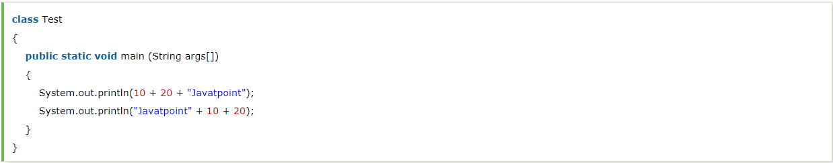

* What is the output of the following Java program?

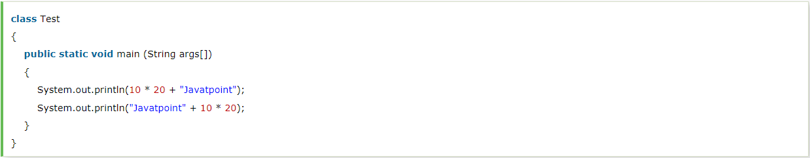

* What is the output of the following Java program?

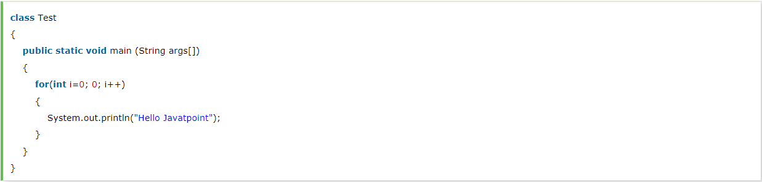

java: incompatible types: int cannot be converted to boolean

## **Core Java - OOPs Concepts: Initial OOPs InMeterview Questions**

* What is object-oriented paradigm?
* What is an object?
* What is the difference between an object-oriented programming language and object-based programming language?
* What will be the initial value of an object reference which is defined as an instance variable?

## **Core Java - OOPs Concepts: Constructor Interview Questions**

* What is the constructor?
* How many types of constructors are used in Java?
* What is the purpose of a default constructor?
* Does constructor return any value?
* Is constructor inherited?
* Can you make a constructor final?
* Can we overload the constructors?
* What do you understand by copy constructor in Java?
* What are the differences between the constructors and methods?
* What is the output of the following Java program?

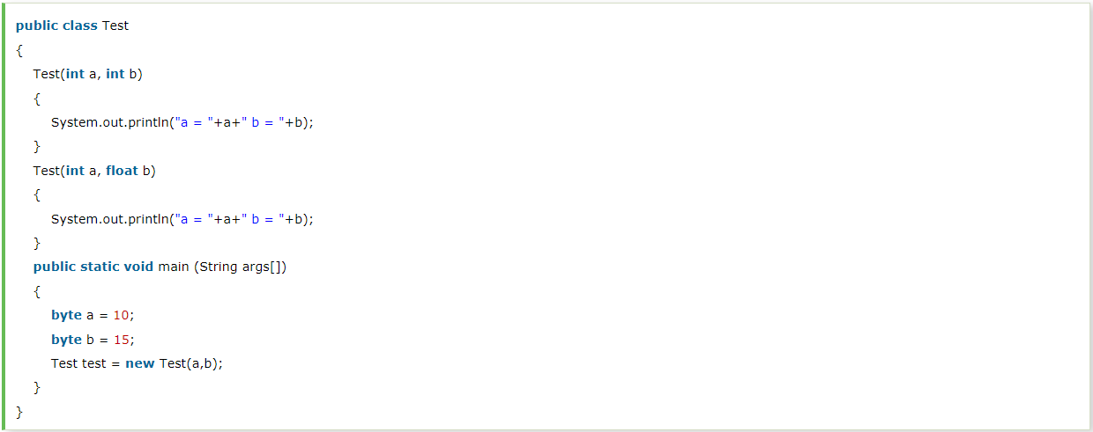

a:10 b20

* What is the output of the following Java program?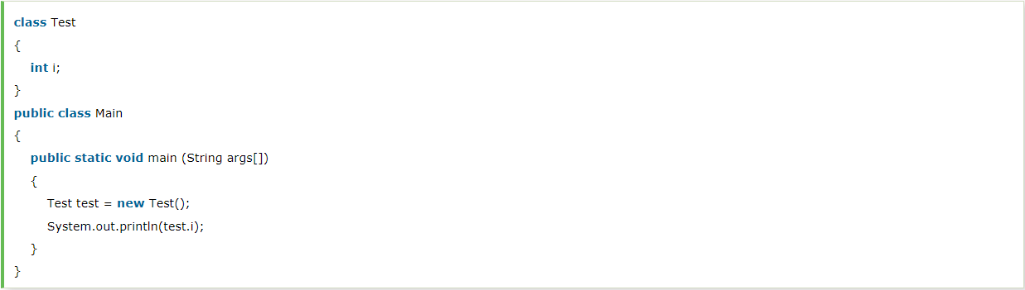

0

* What is the output of the following Java program?

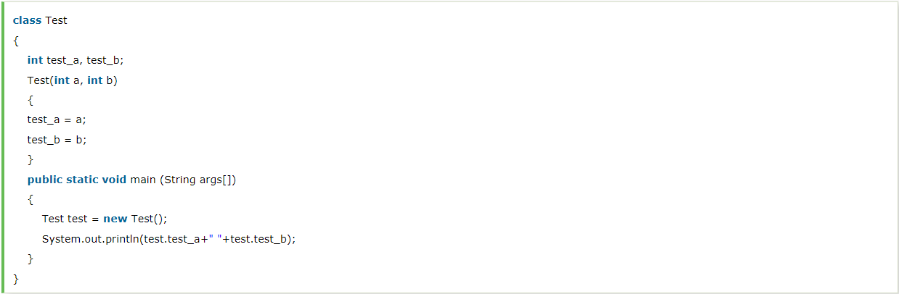

## **Core Java - OOPs Concepts: static keyword Interview Questions**

* What is the static variable?
* What is the static method?
* What are the restrictions that are applied to the Java static methods?
* Why is the main method static?
* Can we override the static methods?
* What is the static block?
* Can we execute a program without main() method?
* What if the static modifier is removed from the signature of the main method?
* What is the difference between static (class) method and instance method?
* Can we make constructors static?
* Can we make the abstract methods static in Java?
* Can we declare the static variables and methods in an abstract class?

## **Core Java - OOPs Concepts: Inheritance Interview Questions**

* What is this keyword in java?
* What are the main uses of this keyword?
* Can we assign the reference to this variable?
* Can this keyword be used to refer static members?
* How can constructor chaining be done using this keyword?
* What are the advantages of passing this into a method instead of the current class object itself?
* What is the Inheritance?
* Why is Inheritance used in Java?
* Which class is the superclass for all the classes?
* Why is multiple inheritances not supported in java?
* What is aggregation?
* What is composition?
* What is the difference between aggregation and composition?
* Why does Java not support pointers?
* What is super in java?
* How can constructor chaining be done by using the super keyword?
* What are the main uses of the super keyword?
* What are the differences between this and super keyword?
* What is the output of the following Java program?

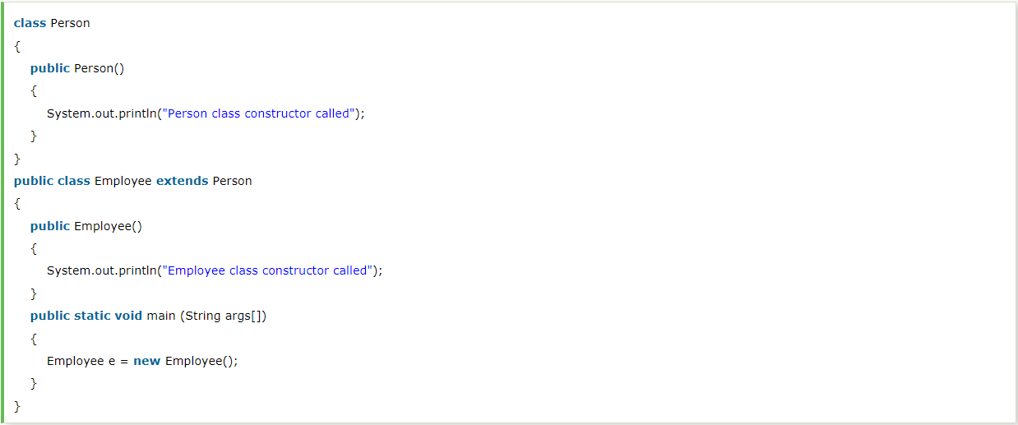

Person class cunstroctor called

Employee class constructor called

* Can you use this() and super() both in a constructor?
* What is object cloning?

## **Core Java - OOPs Concepts: Method Overloading Interview Questions**

* What is method overloading?
* Why is method overloading not possible by changing the return type in java?
* Can we overload the methods by making them static?
* Can we overload the main() method?
* What is method overloading with type promotion?
* What is the output of the following Java program?

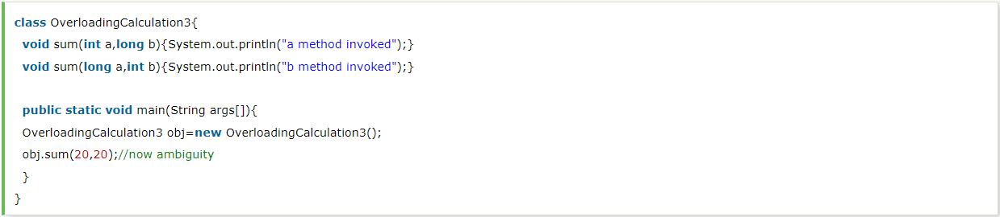

## **Core Java - OOPs Concepts: Method Overriding Interview Questions**

* What is method overriding?
* Can we override the static method?
* Why can we not override static method?
* Can we override the overloaded method?
* Difference between method Overloading and Overriding.
* Can we override the private methods?
* Can we change the scope of the overridden method in the subclass?
* Can we modify the throws clause of the superclass method while overriding it in the subclass?
* What is the output of the following Java program?

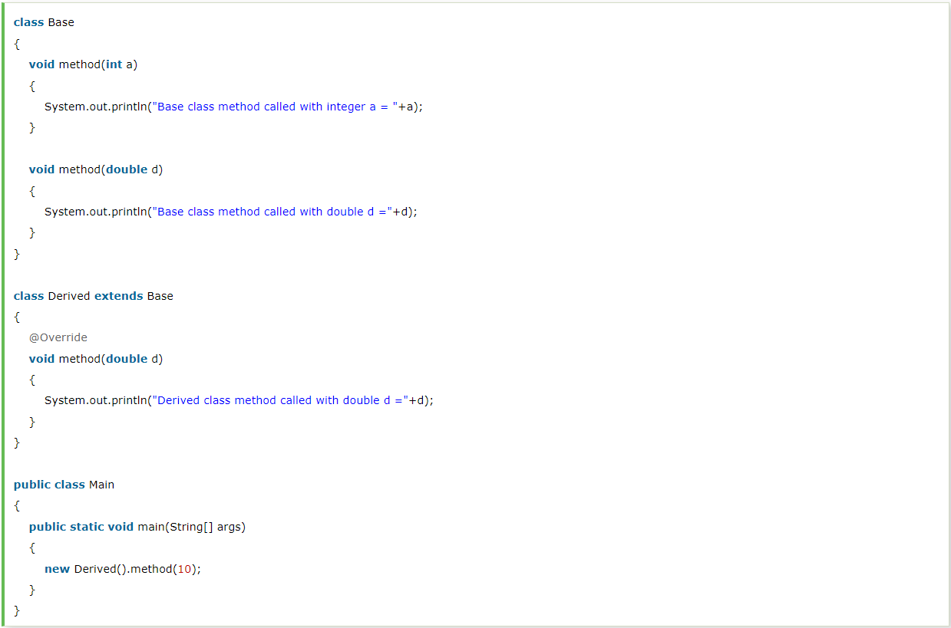

* Can you have virtual functions in Java?
* What is covariant return type?
* What is the output of the following Java program?

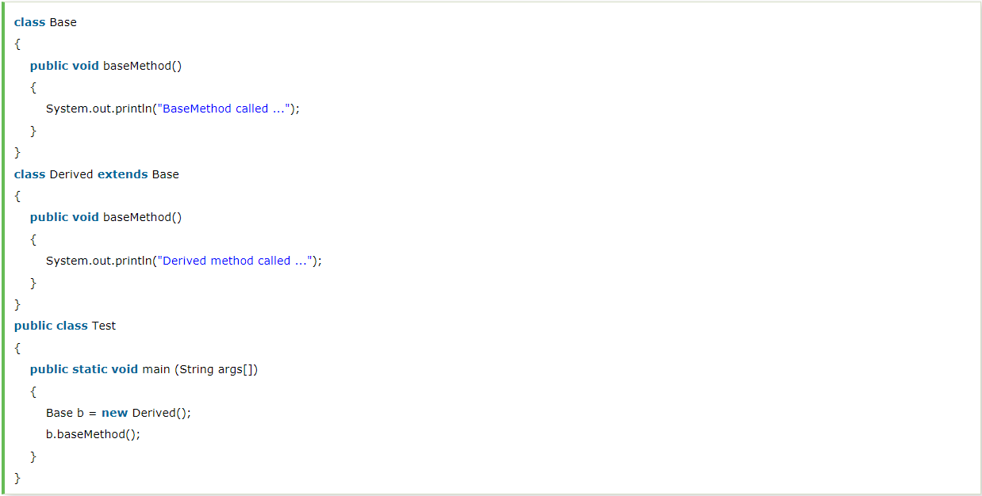

## **Core Java - OOPs Concepts: final keyword Interview Questions**

* What is the final variable?
* What is the final method?
* What is the final class?
* What is the final blank variable?
* Can we initialize the final blank variable?
* Can you declare the main method as final?
* What is the output of the following Java program?

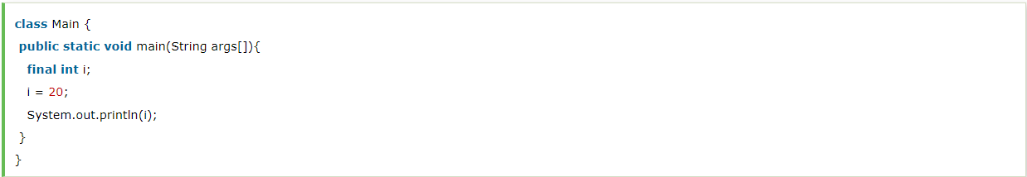

* What is the output of the following Java program?

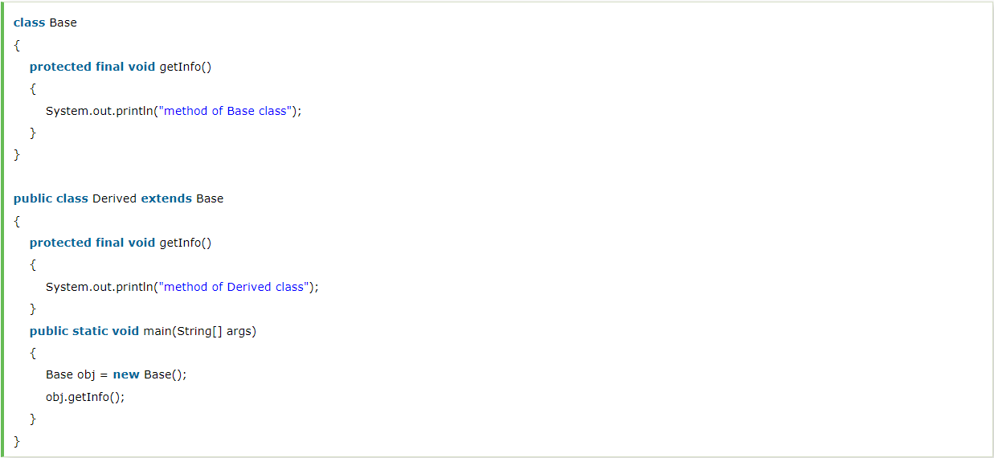

* Can we declare a constructor as final?
* Can we declare an interface as final?
* What is the difference between the final method and abstract method?

## **Core Java - OOPs: Polymorphism Interview Questions**

* What is the difference between compile-time polymorphism and runtime polymorphism? Tell at least 5 points.
* What is Runtime Polymorphism?
* Can you achieve Runtime Polymorphism by data members?
* What is the difference between static binding and dynamic binding?
* What is the output of the following Java program?

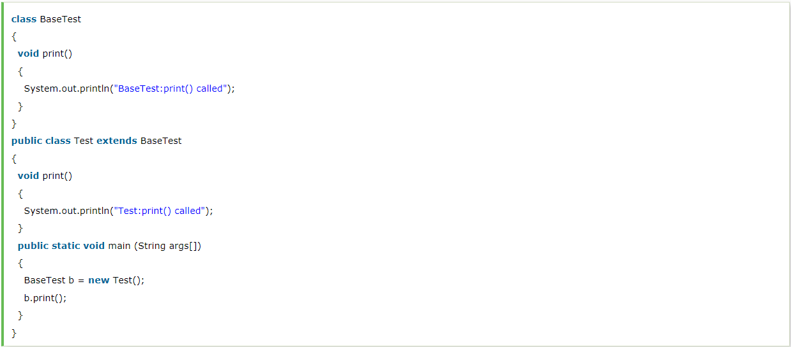

* What is Java instanceOf operator?
* What is abstraction?
* What is the difference between abstraction and encapsulation?
* What is the abstract class?
* Can there be an abstract method without an abstract class?
* Can you use abstract and final both with a method?
* Is it possible to instantiate the abstract class?
* What is the interface?
* Can you declare an interface method static?
* Can the Interface be final?
* What is a marker interface?
* What are the differences between abstract class and interface? Tell atleast 5-10 points.
* Can we define private and protected modifiers for the members in interfaces?
* When can an object reference be cast to an interface reference?
* How to make a read-only class in Java?
* How to make a write-only class in Java?
* What are the advantages of Encapsulation in Java?

## **Core Java - OOPs Concepts: Package Interview Questions**

* What is the package?
* What are the advantages of defining packages in Java?
* How to create packages in Java?
* How can we access some class in another class in Java?
* Do I need to import java.lang package any time? Why?
* Can I import the same package/class twice? Will the JVM load the package twice at runtime?
* What is the static import?

## **Java: Exception Handling Interview Questions**

* How many types of exception can occur in a Java program?
* What is Exception Handling?
* Explain the hierarchy of Java Exception classes?
* What is the difference between Checked Exception and Unchecked Exception? Tell atleast 3-5 points
* What is the base class for Error and Exception?
* Is it necessary that each try block must be followed by a catch block?
* What is the output of the following Java program?

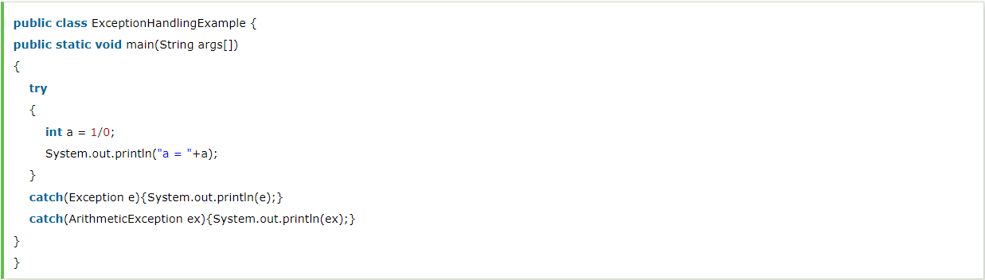

* What is finally block?
* Can finally block be used without a catch?
* Is there any case when finally will not be executed?
* What is the difference between throw and throws?
* What is the output of the following Java program?

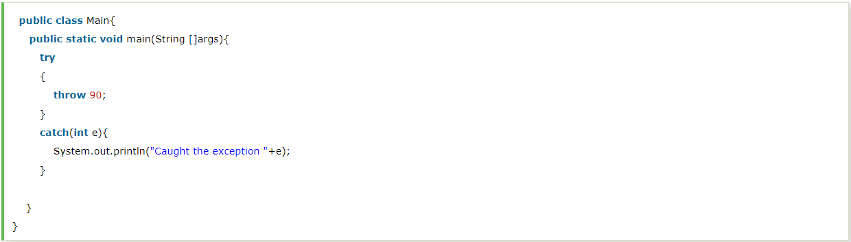

* What is the output of the following Java program?

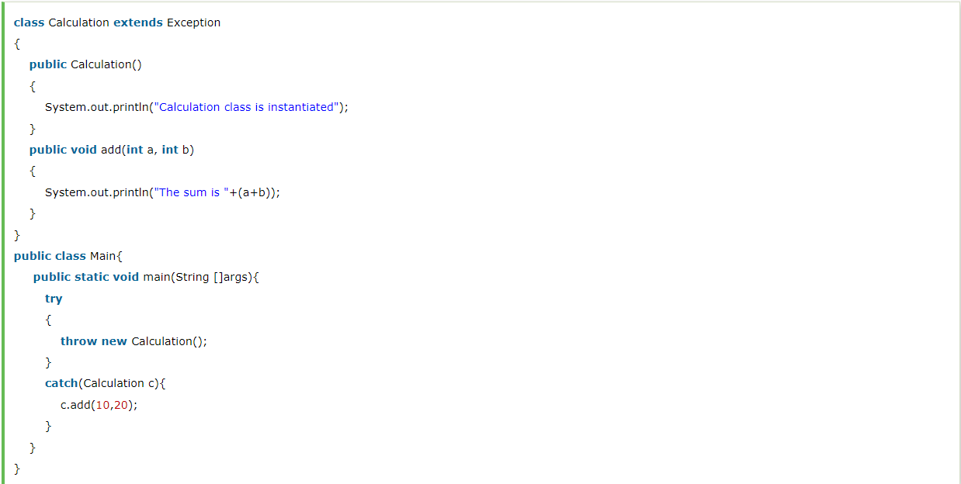

* Can an exception be rethrown?
* Can subclass overriding method declare an exception if parent class method doesn't throw an exception?
* What is exception propagation?
* What is the output of the following Java program?

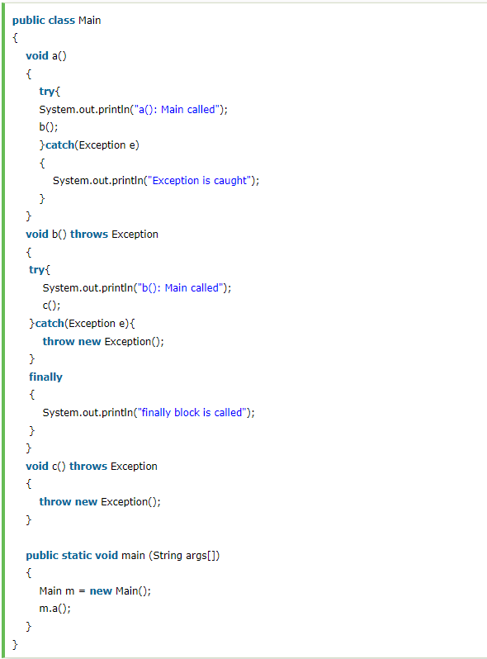

* What is the output of the following Java program?

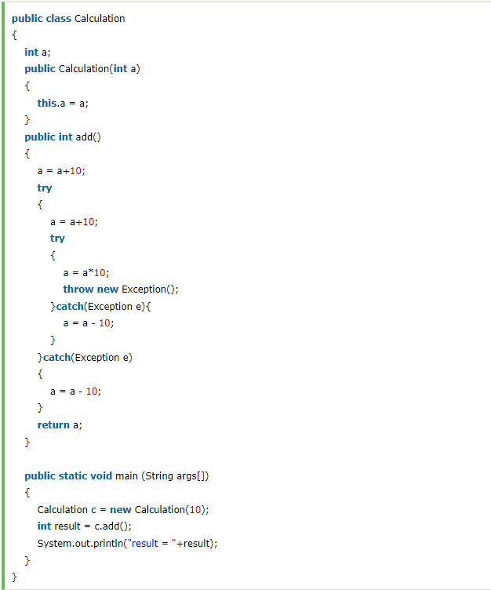

## **Java: String Handling Interview Questions**

* What is String Pool?
* What is the meaning of immutable regarding String?
* Why are the objects immutable in java?
* How many ways can we create the string object?
* How many objects will be created in the following code?
* Why java uses the concept of the string literal?
* How many objects will be created in the following code?
* What is the output of the following Java program?
* What is the output of the following Java program?
* What are the differences between String and StringBuffer?
* What are the differences between StringBuffer and StringBuilder?
* How can we create an immutable class in Java?
* What is the purpose of toString() method in Java?
* Why CharArray() is preferred over String to store the password?
* Write a Java program to count the number of words present in a string?
* Name some classes present in java.util.regex package.
* How the metacharacters are different from the ordinary characters?
* Write a regular expression to validate a password. A password must start with an alphabet and followed by alphanumeric characters; Its length must be in between 8 to 20.
* What is the output of the following Java program?

**import** java.util.regex.*;

**class** RegexExample2{

**public** **static** **void** main(String args[]){

System.out.println(Pattern.matches(".s", "as")); //line 4

System.out.println(Pattern.matches(".s", "mk")); //line 5

System.out.println(Pattern.matches(".s", "mst")); //line 6

System.out.println(Pattern.matches(".s", "amms")); //line 7

System.out.println(Pattern.matches("..s", "mas")); //line 8

}}

## **Core Java: Nested classes and Interfaces Interview Questions**

* What are the advantages of Java inner classes?
* What is a nested class?
* What are the disadvantages of using inner classes?
* What are the types of inner classes (non-static nested class) used in Java?
* Is there any difference between nested classes and inner classes?
* Can we access the non-final local variable, inside the local inner class?
* How many class files are created on compiling the OuterClass in the following program?

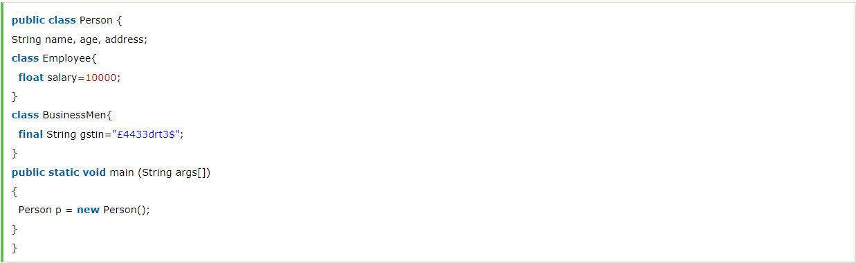

* What are anonymous inner classes?
* What is the nested interface?
* Can a class have an interface?
* Can an Interface have a class?

## **I/O Interview Questions**

* Give the hierarchy of InputStream and OutputStream classes.
* What do you understand by an IO stream?
* What is the difference between the Reader/Writer class hierarchy and the InputStream/OutputStream class hierarchy?
* What are the super most classes for all the streams?
* What are the FileInputStream and FileOutputStream?
* What is the purpose of using BufferedInputStream and BufferedOutputStream classes?
* How to set the Permissions to a file in Java?
* What are FilterStreams?
* What is an I/O filter?
* In Java, How many ways you can take input from the console?

## **Serialization Interview Questions**

* What is serialization?
* How can you make a class serializable in Java?
* How can you avoid serialization in child class if the base cla ss is implementing the Serializable interface?
* Can a Serialized object be transferred via network?
* What is Deserialization?
* What is the transient keyword? Difference between transient and static variable.
* What is Externalizable?
* What is the difference between Serializable and Externalizable interface? Tell atleast 4-5 points

## **Networking Interview Questions**

* Give a brief description of Java socket programming?
* What is Socket?
* What are the steps that are followed when two computers connect through TCP?
* Write a program in Java to establish a connection between client and server?
* How do I convert a numeric IP address like 192.18.97.39 into a hostname like java.sun.com?

## **Reflection Interview Questions**

* What is the reflection?
* What is the purpose of using java.lang.Class class?
* What are the ways to instantiate the Class class?
* What is the output of the following Java program?

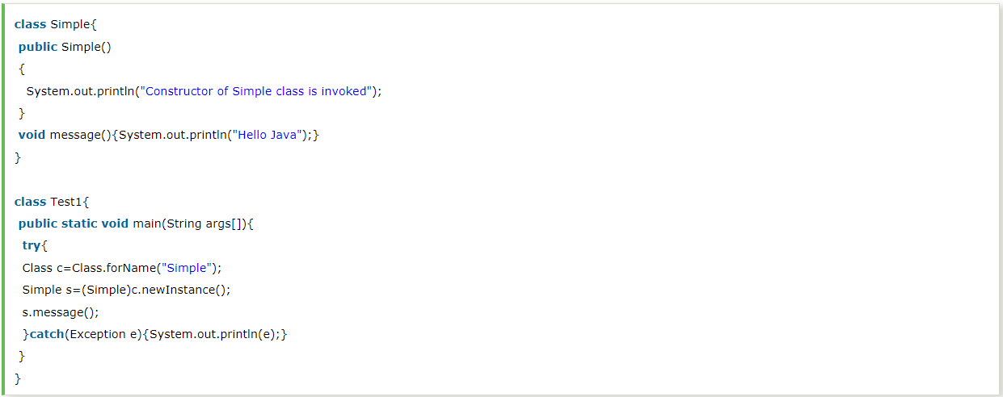

* What is the purpose of using javap?
* Can you access the private method from outside the class?

## **Miscellaneous Interview Questions**

* What are wrapper classes?
* What are autoboxing and unboxing? When does it occur?
* What is the output of the below Java program?
* What is object cloning?
* What are the advantages and disadvantages of object cloning?
* What is a native method?
* What is the purpose of the strictfp keyword?
* What is the purpose of the System class?
* What comes to mind when someone mentions a shallow copy in Java?
* What is a singleton class?
* Write a Java program that prints all the values given at command-line.
* Which containers use a border layout as their default layout?
* Which containers use a FlowLayout as their default layout?
* What are peerless components?
* is there is any difference between a Scrollbar and a ScrollPane?
* What is a lightweight component?
* What is a heavyweight component?

## **Internationalization Interview Questions**

* What is Locale?
* How will you load a specific locale?

## **Java Bean Interview Questions**

* What is a JavaBean?
* What is the purpose of using the Java bean?
* What do you understand by the bean persistent property?

## **Core Java: Data Structure interview questions**

* How to perform Bubble Sort in Java?
* How to perform Binary Search in Java?
* How to perform Selection Sort in Java?
* How to perform Linear Search in Java?
* How to perform merge sort in Java?
* How to perform quicksort in Java?
* Write a program in Java to create a doubly linked list containing n nodes.
* Write a program in Java to find the maximum and minimum value node from a circular linked list.
* Write a program in Java to calculate the difference between the sum of the odd level and even level nodes of a Binary Tree.

## **Core Java: Puzzles interview questions**

* [Dead code and unreachable code in java](https://howtodoinjava.com/puzzles/dead-code-and-unreachable-code-in-java-puzzle/)
* [How to create an instance of any class without using new keyword](https://howtodoinjava.com/puzzles/how-to-create-an-instance-of-any-class-without-using-new-keyword/)
* How to Detect infinite loop in LinkedList with Example
* TreeMap put operation

**Puzzle :**I have given a below map with the following below options,

|  |
| --- |
| Map map = new TreeMap();  map.put("test key 1", "test value 1");  map.put("test key 2", "test value 2");  map.put("test key 3", "test value 3");    System.out.println(map.put("test key 3", "test value 3"));  System.out.println(map.put("test key 4", "test value 4")); |

**Option A)** System.out.println(map.put(“test key 3”, “test value 3”));  
**Answer)** This prints the output as = test value 3

**Option B)** System.out.println(map.put(“test key 4”, “test value 4”));  
**Answer)** This prints the output as = null;

Can anyone please explain why option b is giving us such a behavior?

Also when I print the map after the Option B sysout statement, I have the test key 4 present in it?

1. **Java Best Practices**

* What best practices you follow while writing multi-threaded code in Java?
* Tell me few best practices you apply while using Collections in Java?
* Can you tell us at least 5 best practice you use while using threads in Java?
* Name 5 IO best practices.
* Name 5 JDBC best practices your follow?
* Name couple of method overloading best practices in Java.

1. **Junit**

* How do you test static method? (answer)
* You can use PowerMock library to test static methods in Java.
* How to do you test a method for an exception using JUnit? ([answer](http://javarevisited.blogspot.sg/2013/04/JUnit-tutorial-example-test-exception-thrown-by-java-method.html))
* Which unit testing libraries you have used for testing Java programs? (answer)
* What is the difference between @Before and @BeforeClass annotation? ([answer](http://javarevisited.blogspot.sg/2013/04/JUnit-tutorial-example-test-exception-thrown-by-java-method.html))

1. **JDBC**

* [What is JDBC API and when do we use it?](https://www.journaldev.com/2529/jdbc-interview-questions-and-answers#jdbc-overview)
* [What are different types of JDBC Drivers?](https://www.journaldev.com/2529/jdbc-interview-questions-and-answers#jdbc-driver-types)
* [How does JDBC API helps us in achieving loose coupling between Java Program and JDBC Drivers API?](https://www.journaldev.com/2529/jdbc-interview-questions-and-answers#jdbc-reflection)
* [What is JDBC Connection? Explain steps to get Database connection in a simple java program.](https://www.journaldev.com/2529/jdbc-interview-questions-and-answers#jdbc-connection)
* [What is the use of JDBC DriverManager class?](https://www.journaldev.com/2529/jdbc-interview-questions-and-answers#jdbc-DriverManager)
* [How to get the Database server details in java program?](https://www.journaldev.com/2529/jdbc-interview-questions-and-answers#jdbc-DatabaseMetaData)
* [What is JDBC Statement?](https://www.journaldev.com/2529/jdbc-interview-questions-and-answers#Statement)
* [What is the difference between execute, executeQuery, executeUpdate?](https://www.journaldev.com/2529/jdbc-interview-questions-and-answers#execute-executeQuery-executeUpdate)
* [What is JDBC PreparedStatement?](https://www.journaldev.com/2529/jdbc-interview-questions-and-answers#PreparedStatement)
* [How to set NULL values in JDBC PreparedStatement?](https://www.journaldev.com/2529/jdbc-interview-questions-and-answers#set-null-values)
* [What is the use of getGeneratedKeys() method in Statement?](https://www.journaldev.com/2529/jdbc-interview-questions-and-answers#generated-keys)
* [What are the benefits of PreparedStatement over Statement?](https://www.journaldev.com/2529/jdbc-interview-questions-and-answers#Statement-vs-PreparedStatement)
* [What is the limitation of PreparedStatement and how to overcome it?](https://www.journaldev.com/2529/jdbc-interview-questions-and-answers#PreparedStatement-IN-clause)
* [What is JDBC ResultSet?](https://www.journaldev.com/2529/jdbc-interview-questions-and-answers#ResultSet)
* [What are different types of ResultSet?](https://www.journaldev.com/2529/jdbc-interview-questions-and-answers#ResultSet-Types)
* [What is the use of setFetchSize() and setMaxRows() methods in Statement?](https://www.journaldev.com/2529/jdbc-interview-questions-and-answers#fetchSize-maxRows)
* [How to use JDBC API to call Stored Procedures?](https://www.journaldev.com/2529/jdbc-interview-questions-and-answers#CallableStatement-Stored-Procedure)
* [What is JDBC Batch Processing and what are it’s benefits?](https://www.journaldev.com/2529/jdbc-interview-questions-and-answers#Batch-Processing)
* [What is JDBC Transaction Management and why do we need it?](https://www.journaldev.com/2529/jdbc-interview-questions-and-answers#Transaction-Management)
* [How to rollback a JDBC transaction?](https://www.journaldev.com/2529/jdbc-interview-questions-and-answers#Rollback-Transaction)
* [What is JDBC Savepoint? How to use it?](https://www.journaldev.com/2529/jdbc-interview-questions-and-answers#Savepoint)
* [What is JDBC DataSource and what are its benefits?](https://www.journaldev.com/2529/jdbc-interview-questions-and-answers#DataSource-Benefits)
* [How to achieve JDBC Connection Pooling using JDBC DataSource and JNDI in Apache Tomcat Server?](https://www.journaldev.com/2529/jdbc-interview-questions-and-answers#Connection-Pool-Tomcat)
* [What is Apache DBCP API?](https://www.journaldev.com/2529/jdbc-interview-questions-and-answers#apache-dbcp)
* [What is JDBC Connection isolation levels?](https://www.journaldev.com/2529/jdbc-interview-questions-and-answers#connection-isolation-levels)
* [What is JDBC RowSet? What are different types of RowSet?](https://www.journaldev.com/2529/jdbc-interview-questions-and-answers#RowSet-Types)
* [What is the different between ResultSet and RowSet?](https://www.journaldev.com/2529/jdbc-interview-questions-and-answers#ResultSet-vs-RowSet)
* [What are common JDBC Exceptions?](https://www.journaldev.com/2529/jdbc-interview-questions-and-answers#SQL-Exceptions)
* [What is CLOB and BLOB datatypes in JDBC?](https://www.journaldev.com/2529/jdbc-interview-questions-and-answers#CLOB-BLOB)
* [What is “dirty read” in JDBC? Which isolation level prevents dirty read?](https://www.journaldev.com/2529/jdbc-interview-questions-and-answers#dirty-read-isolation)
* [What is 2 phase commit?](https://www.journaldev.com/2529/jdbc-interview-questions-and-answers#2-phase-commit)
* [What are the different types of locking in JDBC?](https://www.journaldev.com/2529/jdbc-interview-questions-and-answers#locking-types)
* [What do you understand by DDL and DML statements?](https://www.journaldev.com/2529/jdbc-interview-questions-and-answers#DDL-DML-statements)
* [What is difference between java.util.Date and java.sql.Date?](https://www.journaldev.com/2529/jdbc-interview-questions-and-answers#java.util.Date-vs-java.sql.Date)
* [How to insert an image or raw data into database?](https://www.journaldev.com/2529/jdbc-interview-questions-and-answers#insert-binary-data)
* [What is phantom read and which isolation level prevents it?](https://www.journaldev.com/2529/jdbc-interview-questions-and-answers#phantom-read-isolation)
* [What is SQL Warning? How to retrieve SQL warnings in the JDBC program?](https://www.journaldev.com/2529/jdbc-interview-questions-and-answers#SQL-Warnings)
* [How to invoke Oracle Stored Procedure with Database Objects as IN/OUT?](https://www.journaldev.com/2529/jdbc-interview-questions-and-answers#Oracle-STRUCT)
* [When do we get java.sql.SQLException: No suitable driver found?](https://www.journaldev.com/2529/jdbc-interview-questions-and-answers#No-suitable-driver-found-exception)
* [What are JDBC Best Practices?](https://www.journaldev.com/2529/jdbc-interview-questions-and-answers#jdbc-best-practices)

1. **Database & SQL**

* [What are Schema Objects?](https://www.besanttechnologies.com/oracle-interview-questions-and-answers)
* [What is a Table?](https://www.besanttechnologies.com/oracle-interview-questions-and-answers)
* [What is a View?](https://www.besanttechnologies.com/oracle-interview-questions-and-answers)
* [What is an Index?](https://www.besanttechnologies.com/oracle-interview-questions-and-answers)
* [What is a Data file?](https://www.besanttechnologies.com/oracle-interview-questions-and-answers)
* [What is the difference between UNIQUE or PRIMARY KEY Constraint?](https://www.besanttechnologies.com/oracle-interview-questions-and-answers)
* [What is PL/SQL?](https://www.besanttechnologies.com/oracle-interview-questions-and-answers)
* [What is the basic structure of PL/SQL?](https://www.besanttechnologies.com/oracle-interview-questions-and-answers)
* [What is the difference between %ROWTYPE and TYPE RECORD?](https://www.besanttechnologies.com/oracle-interview-questions-and-answers)
* [What is a cursor? Why cursor is required?](https://www.besanttechnologies.com/oracle-interview-questions-and-answers)
* [Explain the two types of cursors?](https://www.besanttechnologies.com/oracle-interview-questions-and-answers)
* [What is Raise_application_error?](https://www.besanttechnologies.com/oracle-interview-questions-and-answers)
* [What is the difference between a PROCEDURE and FUNCTION?](https://www.besanttechnologies.com/oracle-interview-questions-and-answers)
* [What is Overloading of procedures?](https://www.besanttechnologies.com/oracle-interview-questions-and-answers)
* [What is a package? What are the advantages of package?](https://www.besanttechnologies.com/oracle-interview-questions-and-answers)
* [What is difference between TRUNCATE and DELETE?](https://www.besanttechnologies.com/oracle-interview-questions-and-answers)
* [What is a join? Explain the different types of joins?](https://www.besanttechnologies.com/oracle-interview-questions-and-answers)
* [What is a Subquery?](https://www.besanttechnologies.com/oracle-interview-questions-and-answers)
* [What is correlated sub-query?](https://www.besanttechnologies.com/oracle-interview-questions-and-answers)
* [Difference between SUBSTR and INSTR?](https://www.besanttechnologies.com/oracle-interview-questions-and-answers)
* [Explain UNION, MINUS, UNION ALL, INTERSECT?](https://www.besanttechnologies.com/oracle-interview-questions-and-answers)
* [What are the Usages of SAVEPOINTS?](https://www.besanttechnologies.com/oracle-interview-questions-and-answers)
* [What is ROWID?](https://www.besanttechnologies.com/oracle-interview-questions-and-answers)
* [What is PRIMARY KEY, UNIQUE KEY, FOREIGN KEY?](https://www.besanttechnologies.com/oracle-interview-questions-and-answers)
* [What is ON DELETE CASCADE?](https://www.besanttechnologies.com/oracle-interview-questions-and-answers)
* [What is difference between CHAR and VARCHAR2? What is maximum SIZE allowed for each type?](https://www.besanttechnologies.com/oracle-interview-questions-and-answers)
* [How to store the results of a query into a file?](https://www.besanttechnologies.com/oracle-interview-questions-and-answers)
* [Which two statements about subqueries are true? (Choose two.)](https://www.besanttechnologies.com/oracle-interview-questions-and-answers)
* [Which three functions can be used to manipulate character, number, or date column values? (Choose three.)](https://www.besanttechnologies.com/oracle-interview-questions-and-answers)
* [Which statement about a table is true?](https://www.besanttechnologies.com/oracle-interview-questions-and-answers)
* [What will be returned from SIGN(ABS(NVL(-32,0)))?](https://www.besanttechnologies.com/oracle-interview-questions-and-answers)
* [Which functions could you use to strip leading characters from a character string. Select two.](https://www.besanttechnologies.com/oracle-interview-questions-and-answers)
* [All the operators are used in single row subquery except one](https://www.besanttechnologies.com/oracle-interview-questions-and-answers)
* [All the commands executes in iSQLplus except one](https://www.besanttechnologies.com/oracle-interview-questions-and-answers)
* [Ascript file which will be executed automatically in iSQLPlus is](https://www.besanttechnologies.com/oracle-interview-questions-and-answers)
* [A command in iSQL plus is used to give the status of old and new value of variable](https://www.besanttechnologies.com/oracle-interview-questions-and-answers)
* [All commands are used to save the changes of the transaction except one](https://www.besanttechnologies.com/oracle-interview-questions-and-answers)
* [A Clause which is used in joining two tables other than equality operator is](https://www.besanttechnologies.com/oracle-interview-questions-and-answers)
* [A Clause which is the pseudocolumn used to know the current value of the sequence](https://www.besanttechnologies.com/oracle-interview-questions-and-answers)
* [A Query which is used in top-N analysis is](https://www.besanttechnologies.com/oracle-interview-questions-and-answers)
* [An operator is used to get and display the redundant records](https://www.besanttechnologies.com/oracle-interview-questions-and-answers)
* [All the datatypes with respect to Oracle 9i is true except one](https://www.besanttechnologies.com/oracle-interview-questions-and-answers)
* [What is database?](https://www.besanttechnologies.com/oracle-interview-questions-and-answers)
* [To select records from the given row?](https://www.besanttechnologies.com/oracle-interview-questions-and-answers)
* [To check the leap year](https://www.besanttechnologies.com/oracle-interview-questions-and-answers)
* [To delete duplicate records](https://www.besanttechnologies.com/oracle-interview-questions-and-answers)
* [To keep latest single record](https://www.besanttechnologies.com/oracle-interview-questions-and-answers)
* [To select second max salary](https://www.besanttechnologies.com/oracle-interview-questions-and-answers)
* [To select nth max salary](https://www.besanttechnologies.com/oracle-interview-questions-and-answers)
* [To select nth min salary](https://www.besanttechnologies.com/oracle-interview-questions-and-answers)
* [To select top(n) max salaries](https://www.besanttechnologies.com/oracle-interview-questions-and-answers)
* [To select top(n) min salaries](https://www.besanttechnologies.com/oracle-interview-questions-and-answers)
* [To select records from particular row(the remaining rows)](https://www.besanttechnologies.com/oracle-interview-questions-and-answers)
* [to select first n rows](https://www.besanttechnologies.com/oracle-interview-questions-and-answers)
* [Explain the difference between trigger and stored procedure.](https://www.besanttechnologies.com/oracle-interview-questions-and-answers)
* [Differences between DATE and TIMESTAMP in Oracle](https://www.besanttechnologies.com/oracle-interview-questions-and-answers)
* [Create a copy of EMP table without any data?](https://www.besanttechnologies.com/oracle-interview-questions-and-answers)
* [Delete the 10th record of EMP table?](https://www.besanttechnologies.com/oracle-interview-questions-and-answers)
* [Find all the departments which have more than 3 employees?](https://www.besanttechnologies.com/oracle-interview-questions-and-answers)
* [Display the manager who is having maximum number of employees working under him?](https://www.besanttechnologies.com/oracle-interview-questions-and-answers)
* [Display the name of employees who joined on the same date?](https://www.besanttechnologies.com/oracle-interview-questions-and-answers)
* [Delete those employees who joined the company 10 years back from today?](https://www.besanttechnologies.com/oracle-interview-questions-and-answers)
* [Display those employees whose salary is ODD value?](https://www.besanttechnologies.com/oracle-interview-questions-and-answers)
* [Find out the number of employees whose salary is greater than their manager salary?](https://www.besanttechnologies.com/oracle-interview-questions-and-answers)
* [Select the count of employees in each dept where count is greater than 3?](https://www.besanttechnologies.com/oracle-interview-questions-and-answers)
* [Display name of those employees who are getting the highest salary?](https://www.besanttechnologies.com/oracle-interview-questions-and-answers)
* [What is a transaction ?](https://www.besanttechnologies.com/oracle-interview-questions-and-answers)
* [What is implicit cursor and how is it used by Oracle ?](https://www.besanttechnologies.com/oracle-interview-questions-and-answers)
* [Which of the following is not a schema object : Indexes, tables, public synonyms, triggers and packages ?](https://www.besanttechnologies.com/oracle-interview-questions-and-answers)
* [Is there a PL/SQL Engine in SQL*Plus?](https://www.besanttechnologies.com/oracle-interview-questions-and-answers)
* [Can one read/write files from PL/SQL?](https://www.besanttechnologies.com/oracle-interview-questions-and-answers)
* [How can I protect my PL/SQL source code?](https://www.besanttechnologies.com/oracle-interview-questions-and-answers)
* [Can one use dynamic SQL within PL/SQL? OR Can you use a DDL in a procedure ? How ?](https://www.besanttechnologies.com/oracle-interview-questions-and-answers)
* [What are the various types of parameter modes in a procedure ?](https://www.besanttechnologies.com/oracle-interview-questions-and-answers)
* [What are the constructs of a procedure, function or a package ?](https://www.besanttechnologies.com/oracle-interview-questions-and-answers)
* [Why Create or Replace and not Drop and recreate procedures ?](https://www.besanttechnologies.com/oracle-interview-questions-and-answers)
* [Can you pass parameters in packages ? How ?](https://www.besanttechnologies.com/oracle-interview-questions-and-answers)
* [What are the parts of a database trigger ?](https://www.besanttechnologies.com/oracle-interview-questions-and-answers)
* [What are the various types of database triggers?](https://www.besanttechnologies.com/oracle-interview-questions-and-answers)
* [What is the advantage of a stored procedure over a database trigger ?](https://www.besanttechnologies.com/oracle-interview-questions-and-answers)
* [What are cascading triggers? What is the maximum no of cascading triggers at a time?](https://www.besanttechnologies.com/oracle-interview-questions-and-answers)
* [What are mutating triggers?](https://www.besanttechnologies.com/oracle-interview-questions-and-answers)
* [What are constraining triggers?](https://www.besanttechnologies.com/oracle-interview-questions-and-answers)
* [Describe Oracle database's physical and logical structure?](https://www.besanttechnologies.com/oracle-interview-questions-and-answers)
* [Can you increase the size of a tablespace? How?](https://www.besanttechnologies.com/oracle-interview-questions-and-answers)
* [What is the use of Control files?](https://www.besanttechnologies.com/oracle-interview-questions-and-answers)
* [What is the use of Data Dictionary?](https://www.besanttechnologies.com/oracle-interview-questions-and-answers)
* [What are the states of a rollback segment? What is the difference between partly available and needs recovery?](https://www.besanttechnologies.com/oracle-interview-questions-and-answers)
* [What is the maximum no.of columns a table can have ?](https://www.besanttechnologies.com/oracle-interview-questions-and-answers)
* [Can you pass a parameter to a cursor ?](https://www.besanttechnologies.com/oracle-interview-questions-and-answers)
* [What are the various types of RollBack Segments ?](https://www.besanttechnologies.com/oracle-interview-questions-and-answers)
* [What are the disadvantages of SQL ?](https://www.besanttechnologies.com/oracle-interview-questions-and-answers)
* [When to create indexes ?](https://www.besanttechnologies.com/oracle-interview-questions-and-answers)
* [How can you avoid indexes ?](https://www.besanttechnologies.com/oracle-interview-questions-and-answers)
* [What is the difference between a view and a synonym?](https://www.besanttechnologies.com/oracle-interview-questions-and-answers)
* [What is the difference between foreign key and reference key?](https://www.besanttechnologies.com/oracle-interview-questions-and-answers)
* [What is a package cursor?](https://www.besanttechnologies.com/oracle-interview-questions-and-answers)
* [What are snap shots and views](https://www.besanttechnologies.com/oracle-interview-questions-and-answers)

1. **Web services (SOAP & REST)**

* [What is a Web Service?](https://www.journaldev.com/9193/web-services-interview-questions-soap-restful#what-is-web-service)
* [What are the advantages of Web Services?](https://www.journaldev.com/9193/web-services-interview-questions-soap-restful#advantages-of-web-services)
* [What are different types of Web Services?](https://www.journaldev.com/9193/web-services-interview-questions-soap-restful#types-of-web-services)
* [What is SOAP?](https://www.journaldev.com/9193/web-services-interview-questions-soap-restful#soap-definition)
* [What are advantages of SOAP Web Services?](https://www.journaldev.com/9193/web-services-interview-questions-soap-restful#soap-advantages)
* [What are disadvantages of SOAP Web Services?](https://www.journaldev.com/9193/web-services-interview-questions-soap-restful#soap-disadvantages)
* [What is WSDL?](https://www.journaldev.com/9193/web-services-interview-questions-soap-restful#wsdl-definition)
* [What are different components of WSDL?](https://www.journaldev.com/9193/web-services-interview-questions-soap-restful#wsdl-components)
* [What is UDDI?](https://www.journaldev.com/9193/web-services-interview-questions-soap-restful#uddi-definition)
* [What is difference between Top Down and Bottom Up approach in SOAP Web Services?](https://www.journaldev.com/9193/web-services-interview-questions-soap-restful#soap-ws-approach)
* [What is REST Web Services?](https://www.journaldev.com/9193/web-services-interview-questions-soap-restful#rest-web-services)
* [What are advantages of REST web services?](https://www.journaldev.com/9193/web-services-interview-questions-soap-restful#rest-advantages)
* [What are disadvantages of REST web services?](https://www.journaldev.com/9193/web-services-interview-questions-soap-restful#rest-disadvantages)
* [What is a Resource in Restful web services?](https://www.journaldev.com/9193/web-services-interview-questions-soap-restful#restful-resource)
* [What are different HTTP Methods supported in Restful Web Services?](https://www.journaldev.com/9193/web-services-interview-questions-soap-restful#http-methods)
* [Compare SOAP and REST web services?](https://www.journaldev.com/9193/web-services-interview-questions-soap-restful#soap-vs-rest)
* [What are different ways to test web services?](https://www.journaldev.com/9193/web-services-interview-questions-soap-restful#web-services-testing)
* [Can we maintain user session in web services?](https://www.journaldev.com/9193/web-services-interview-questions-soap-restful#web-services-seesion)
* [What is difference between SOA and Web Services?](https://www.journaldev.com/9193/web-services-interview-questions-soap-restful#soa-vs-web-services)
* [What is the use of Accept and Content-Type Headers in HTTP Request?](https://www.journaldev.com/9193/web-services-interview-questions-soap-restful#http-request-headers)
* [How would you choose between SOAP and REST web services?](https://www.journaldev.com/9193/web-services-interview-questions-soap-restful#soap-rest-choice)
* [What is JAX-WS API?](https://www.journaldev.com/9193/web-services-interview-questions-soap-restful#jax-ws-api)
* [Name some frameworks in Java to implement SOAP web services?](https://www.journaldev.com/9193/web-services-interview-questions-soap-restful#java-soap-frameworks)
* [Name important annotations used in JAX-WS API?](https://www.journaldev.com/9193/web-services-interview-questions-soap-restful#jax-ws-annotations)
* [What is use of javax.xml.ws.Endpoint class?](https://www.journaldev.com/9193/web-services-interview-questions-soap-restful#jax-ws-endpoint)
* [What is the difference between RPC Style and Document Style SOAP web Services?](https://www.journaldev.com/9193/web-services-interview-questions-soap-restful#soap-rpc-vs-document)
* [How to get WSDL file of a SOAP web service?](https://www.journaldev.com/9193/web-services-interview-questions-soap-restful#soap-wsdl-url)
* [What is sun-jaxws.xml file?](https://www.journaldev.com/9193/web-services-interview-questions-soap-restful#soap-config-file)
* [What is JAX-RS API?](https://www.journaldev.com/9193/web-services-interview-questions-soap-restful#jax-rs-api)
* [Name some implementations of JAX-RS API?](https://www.journaldev.com/9193/web-services-interview-questions-soap-restful#jax-rs-implementations)
* [What is wsimport utility?](https://www.journaldev.com/9193/web-services-interview-questions-soap-restful#wsimport-utility)
* [Name important annotations used in JAX-RS API?](https://www.journaldev.com/9193/web-services-interview-questions-soap-restful#jax-rs-annotations)
* [What is the use of @XmlRootElement annotation?](https://www.journaldev.com/9193/web-services-interview-questions-soap-restful#xmlrootelement-jaxb)
* [How to set different status code in HTTP response?](https://www.journaldev.com/9193/web-services-interview-questions-soap-restful#http-response-code)
* What is HTTP Basic Authentication and how it works?
* How to display custom error pages using RestFull web services ?
* Which HTTP methods are supported by RestFull web services ?
* What happens if RestFull resources are accessed by multiple clients ? do you need to make it thread-safe?
* Can you tell me which API can be used to develop RESTFul web service in Java?
* How do you configure RESTFul web service?
* How you apply security in RESTFul web services?
* Have you used securing RESTful APIs with HTTP Basic Authentication
* How you maintain session in RESTful services?
* Have you used Jersey API to develop RESTful services in Java?
* How you test RESTful web services?
* What is WADL in RESTFul?
* What do you understand by payload in RESTFul?
* Can you do payload in GET method?
* Can you do payload in HTTP DELETE?
* How much maximum pay load you could do in POST method?
* If you have to develop web services which one you will choose SOAP OR RESTful and why?
* What framework you had used to develop RESTFul services?
* What is Safe Methods in HTTP?
* What are Idempotent Methods in HTTP?
* [why should you use PUT over POST to update a resource in REST](http://java67.blogspot.com/2015/09/top-10-restful-web-service-interview-questions-answers.html).
* What REST stands for?
* What is REST?
* Name some of the commonly used HTTP methods used in REST based architecture?
* What are webservices?
* What are RESTful webservices?
* What is a Resource in REST?
* How to represent a resource in REST?
* REST uses various representations to represent a resource where text, JSON, XML. XML and JSON are the most popular representations of resources.
* What are the best practices to design a resource representation?
* Which protocol is used by RESTful webservices?
* What is messaging in RESTful webservices?
* What are the core components of a HTTP Request?
* What are the core components of a HTTP response?
* What is addressing in RESTful webservices?
* What is URI?
* What is purpose of a URI in REST based webservices?
* What is format of a URI in REST architecture?
* What is the purpose of HTTP Verb in REST based webservices?
* What are the best practices to create a standard URI for a web service?
* What is statelessness in RESTful Webservices?
* What are the advantages of statelessness in RESTful Webservices?
* What are the disadvantages of statelessness in RESTful Webservices?
* What do you mean by idempotent operation?
* Which type of Webservices methods are to be idempotent?
* Which type of Webservices methods are to be read only?
* What is the difference between PUT and POST operations?
* What should be the purpose of OPTIONS method of RESTful web services?
* What should be the purpose of HEAD method of RESTful web services?
* What is caching?
* Which header of HTTP response, provides the date and time of the resource when it was created?
* Which header of HTTP response, provides the date and time of the resource when it was last modified?
* Which header of HTTP response provides control over caching?
* Which header of HTTP response sets expiration date and time of caching?
* Which directive of Cache Control Header of HTTP response indicates that resource is cachable by any component?
* Which directive of Cache Control Header of HTTP response indicates that resource is cachable by only client and server, no intermediary can cache the resource?
* Which directive of Cache Control Header of HTTP response indicates that resource is not cachable?
* Which directive of Cache Control Header of HTTP response can set the time limit of caching?
* Which directive of Cache Control Header of HTTP response provides indication to server to revalidate resource if max-age has passed?
* What are the best practices for caching?
* What are the best practices to be followed while designing a secure RESTful web service?
* What is the purpose of HTTP Status Code?
* What HTTP Status Code 200 states?
* What HTTP Status Code 201 states?
* What HTTP Status Code 204 states?
* What HTTP Status Code 304 states?
* What HTTP Status Code 400 states?
* What HTTP Status Code 401 states?
* What HTTP Status Code 404 states?
* What HTTP Status Code 409 states?
* What HTTP Status Code 500 states?
* What is JAX-RS?

1. **Spring**

## Spring - [General Questions](https://www.edureka.co/blog/interview-questions/spring-interview-questions/#GeneralQuestion)

* [What is Spring Framework?](https://www.baeldung.com/spring-interview-questions#Q1)
* [What are the benefits of using Spring?](https://www.baeldung.com/spring-interview-questions#Q2) Or What are the advantages of spring framework?
* [What Spring sub-projects do you know? Describe them briefly.](https://www.baeldung.com/spring-interview-questions#Q3)
* What are the modules of spring framework?
* What is a Spring configuration file?
* [How can we inject beans in Spring?](https://www.baeldung.com/spring-interview-questions#Q5)
* Differentiate between constructor injection and setter injection.
* [Which is the best way of injecting beans and why](https://www.baeldung.com/spring-interview-questions#Q6)
* [What is the difference between BeanFactory and ApplicationContext?](https://www.baeldung.com/spring-interview-questions#Q7)
* What is autowiring in spring? What are the autowiring modes?
* [Are singleton beans thread-safe?](https://www.baeldung.com/spring-interview-questions#Q11)
* [What does the Spring bean lifecycle look like?](https://www.baeldung.com/spring-interview-questions#Q12)
* [What is the Spring Java-Based Configuration?](https://www.baeldung.com/spring-interview-questions#Q13)
* [Can we have multiple Spring configuration files in one project?](https://www.baeldung.com/spring-interview-questions#Q14)
* [What is Spring Security?](https://www.baeldung.com/spring-interview-questions#Q15)
* [What is Spring Boot?](https://www.baeldung.com/spring-interview-questions#Q16)
* [Name some of the Design Patterns used in the Spring Framework?](https://www.baeldung.com/spring-interview-questions#Q17)
* [How does the scope Prototype work?](https://www.baeldung.com/spring-interview-questions#Q18)

## Spring - [Dependency Injection/ IoC](https://www.edureka.co/blog/interview-questions/spring-interview-questions/#DI)

* In how many ways can Dependency Injection be done? Or What are the different types of IoC (dependency injection)?
* [What is Dependency Injection?](https://www.baeldung.com/spring-interview-questions#Q4) OR What is IOC and DI?
* What is the role of IOC container in spring?
* What are the types of IOC container in spring?
* List some of the benefits of IoC.
* [How to define the scope of a bean?](https://www.baeldung.com/spring-interview-questions#Q10)

## [Spring Beans](https://www.edureka.co/blog/interview-questions/spring-interview-questions/#Beans)

* Explain Spring Beans? OR [What is a Spring Bean?](https://www.baeldung.com/spring-interview-questions#Q8)
* How configuration metadata is provided to the Spring container?
* How many bean scopes are supported by Spring?
* What are the different bean scopes in spring?
* In which scenario, you will use singleton and prototype scope?
* What is the Bean life cycle in Spring Bean Factory Container?
* Which are the important beans lifecycle methods? Can you override them?
* [What is the default bean scope in Spring framework?](https://www.baeldung.com/spring-interview-questions#Q9)
* Explain inner beans in Spring.
* Define Bean Wiring.
* What do you understand by auto wiring and name the different modes of it? Or Explain different modes of autowiring?
* What are the limitations with auto wiring?
* How can you inject a Java Collection in Spring?
* Can you inject null and empty string values in Spring?

## [Spring Annotations](https://www.edureka.co/blog/interview-questions/spring-interview-questions/#Annotations)

* What do you mean by Annotation-based container configuration?
* What is Spring Java-Based Configuration? Give some annotation example.
* What are some of the important Spring annotations?
* How annotation wiring can be turned on in Spring?
* What’s the difference between @Component, @Controller, @Repository & @Service annotations in Spring?
* What do you understand by @Required annotation?
* What do you understand by @Autowired annotation?
* What do you understand by @Qualifier annotation?
* What do you understand by @RequestMapping annotation?
* What does the @RequestParam annotation do?
* What is the importance of the annotation @Primary
* Can we send an Object as the response of Controller handler method?
* How do you turn on annotation wiring?

## [Spring Data Access](https://www.edureka.co/blog/interview-questions/spring-interview-questions/#DA)

* Which classes are present in spring JDBC API?
* How can JDBC be used more efficiently in the Spring framework?
* How can you fetch records by spring JdbcTemplate?
* What is the advantage of NamedParameterJdbcTemplate?
* What is Spring JDBCTemplate class and how to use it?
* What is the difference between JDBC and Spring JDBC?
* Spring DAO support
* What are the ways to access Hibernate by using Spring?
* ORM’s Spring support
* [What is Spring JDBCTemplate class and how to use it?](https://www.baeldung.com/spring-interview-questions#Q22)
* [How would you enable transactions in Spring and what are their benefits?](https://www.baeldung.com/spring-interview-questions#Q23)
* [What is Spring DAO?](https://www.baeldung.com/spring-interview-questions#Q24)

## [Spring AOP](https://www.edureka.co/blog/interview-questions/spring-interview-questions/#AOP)

* Describe Spring AOP?
* What is the difference between concern and cross-cutting concern in Spring AOP?
* What are the available AOP implementations?
* What are the different advice types in spring?
* What is Spring AOP Proxy?
* What is Introduction?
* What is joint point and Point cut?
* What is Weaving in AOP?

## [Spring Transaction](https://www.edureka.co/blog/interview-questions/spring-interview-questions/#AOP)

* Types of the transaction management Spring support
* What are the benefits of the Spring Framework’s transaction management?
* Which Transaction management type is preferable?

## [Spring MVC](https://www.edureka.co/blog/interview-questions/spring-interview-questions/#MVC)

* [How to Get ServletContext and ServletConfig Objects in a Spring Bean?](https://www.baeldung.com/spring-interview-questions#Q19)
* [What is a Controller in Spring MVC?](https://www.baeldung.com/spring-interview-questions#Q20)
* [How does the @RequestMapping annotation work?](https://www.baeldung.com/spring-interview-questions#Q21)
* What are the minimum configurations needed to create Spring MVC application?
* List out all the concepts that are available in the MVC Architecture?
* What is DispatcherServlet
* What is WebApplicationContext
* What is Controller in Spring MVC framework?
* How would you relate Spring MVC Framework to MVC architecture?
* What is ViewResolver in Spring MVC?
* What is a MultipartResolver and when its used?
* How to upload file in Spring MVC Application?
* How to validate form data in Spring Web MVC Framework?
* What is Spring MVC Interceptor and how to use it?

## [Spring Authentication and authorization](https://www.edureka.co/blog/interview-questions/spring-interview-questions/#MVC)

* What is Spring Security?
* What Is the Delegating Filter Proxy? Or How is Security mechanism implemented using Spring?
* What Is the Security Filter Chain?
* What Is Mandatory Filter Name Main Purpose?
* Are You Able to Add And/or Replace Individual Filters?
* Is It Enough to Hide Sections of My Output (e.g. Jsp-page)?
* Why Do You Need the Intercept-url?
* In Which Order Do You Have to Write Multiple Intercept-url’s?
* Why Do You Need Method Security? What Type of Object Is Typically Secured At The Method Level.
* Is Security A Cross Cutting Concern? How Is It Implemented Internally?
* What Do @secured and @rolesallowed Do? What Is the Difference Between Them?
* What's the difference between @Secured and @PreAuthorize in spring security?
* What Is A Security Context?
* How Is A Principal Defined?
* What Is Authentication and Authorization? Which Must Come First?
* In Which Security Annotation Are You Allowed to Use Spel?
* Does Spring Security Support Password Hashing? What Is Salting?
* Which Filter Class Is Needed for Spring Security?
* What Are Access Controls in Spring Security?
* How to Restrict Static Resources Processed by Spring Security Filters?
* From the Applications Perspective, How Many User Roles Needed in Spring Security?
* Will Spring Security Secures All the Applications?
* How to Add Security to Method Calls Made on Spring Beans in The Application Context?
* Which Java and Spring Version Are Needed for Spring Security?
* What Are All Security Layers in Spring Security Framework?
* When I Login in The Application Where Spring Security Is Applied and Got the Messages "bad Credentials". What Is Wrong?
* When I Try to Login, Application Goes in Endless Loop. What Is Wrong?
* How to configure Spring Security using Spring MVC?
* What is the difference between ROLE_USER and ROLE_ANONYMOUS in a Spring intercept url configuration?
* How to configure Spring Security with in-memory configuration?
* What is Oauth?
* How do I enable Spring Security in Java Web application?
* Which filter class is required for spring security?
* Minimum java and spring version required for spring security?
* Mention other filters in spring security and its purpose.
* Types of authentication that spring supports.
* Explain BASIC authentication.
* Explain digest authentication.
* Does Spring Security support password hashing?
* What is salting in spring security?
* How to restrict static resources using spring security?

1. **JSP**

* What is JSP?
* What are the life-cycle methods for a JSP?
* List out some advantages of using JSP.
* Give the syntax for JSP comments.
* What are JSP Directives?
* What is the difference between hide comment and output comment?
* What are the JSP implicit objects?
* What is the difference between include directive and include action?
* Is JSP technology extensible?
* How can I prevent the output of my JSP or Servlet pages from being cached by the browser? (OR) How to disable caching on the back button of the browser?
* How can we handle the exceptions in JSP?
* What are the two ways to include the result of another page. ?
* How can we forward the request from JSP page to the servlet?
* Can we use the exception implicit object in any JSP page?
* How is JSP used in the MVC model?
* What are context initialization parameters?
* What are the different scope values for the <jsp:useBean> tag?
* What do JSP literals consist of?
* What is the purpose of <jsp:useBean>?
* What is the purpose of <jsp:setProperty>?
* What is the purpose of <jsp:getProperty>?
* List out the various scope values of JSP action.
* What is the use of 'out' implicit object?
* Give the use of session object.
* Give the use of exception object.
* What is the difference between ServletContext and PageContext?-
* What is the difference in using request.getRequestDispatcher() and context.getRequestDispatcher()?
* What is EL in JSP?
* What are the primary differences between the JSP custom tags and java beans?
* Can an interface be implemented in the JSP file?
* What is JSTL?
* How many tags are provided in JSTL?
* Which directive is used in JSP custom tag?
* What are the three tags used in JSP bean development?
* How to disable session in JSP?
* List the various action tags used in JSP.
* Explain the steps for creating custom tags in JSP?
* How can the applets be displayed in the JSP? Explain with an example.
* What is Expression language in JSP?
* Explain various implicit objects in expression language.

1. **Servlet**

* What is different between web server and application server?
* Which HTTP method is non-idempotent?
* What is the difference between GET and POST method?
* What is MIME Type?
* What is a web application and what is it’s directory structure?
* What is a servlet?
* What are the advantages of Servlet over CGI?
* What are common tasks performed by Servlet Container?
* What is ServletConfig object?
* What is ServletContext object?
* What is difference between ServletConfig and ServletContext?
* What is Request Dispatcher? What is the purpose of RequestDispatcher Interface?
* What is difference between PrintWriter and ServletOutputStream?
* Can we get PrintWriter and ServletOutputStream both in a servlet?
* How can we create deadlock situation in servlet?
* What is the use of servlet wrapper classes?
* What is SingleThreadModel interface?
* Do we need to override service() method?
* Is it good idea to create servlet constructor?
* What is difference between GenericServlet and HttpServlet?
* What is the inter-servlet communication?
* Are Servlets Thread Safe? How to achieve thread safety in servlets?
* What is servlet attributes and their scope?
* How do we call one servlet from another servlet?
* How can we invoke another servlet in a different application?
* What is difference between ServletResponsesendRedirect() and RequestDispatcher forward() method?
* Why HttpServlet class is declared abstract?
* What are the phases of servlet life cycle?
* What are life cycle methods of a servlet?
* why we should override only no-agrsinit() method.
* What is URL Encoding?
* What are different methods of session management in servlets?
* What is URL Rewriting?
* How does Cookies work in Servlets?
* How to notify an object in session when session is invalidated or timed-out?
* What is the difference between encodeRedirectUrl and encodeURL?
* Why do we have servlet filters?
* What is the effective way to make sure all the servlets are accessible only when user has a valid session?
* Why do we have servlet listeners?
* How to handle exceptions thrown by application with another servlet?
* What is a deployment descriptor?
* How to make sure a servlet is loaded at the application startup?
* How to get the actual path of servlet in server?
* How to get the server information in a servlet?
* Write a servlet to upload file on server.
* How do we go with database connection and log4j integration in servlet?
* How to get the IP address of client in servlet?
* What are important features of Servlet 3?
* What are different ways for servlet authentication?
* How can we achieve transport layer security for our web application?
* What is the life-cycle of a servlet?
* What are the life-cycle methods for a servlet?
* How many objects of a servlet is created?
* When servlet object is created?
* What is servlet collaboration?
* Can you call a jsp from the servlet?
* What is Session Tracking?
* What are Cookies?
* What is difference between Cookies and HttpSession?
* How can we perform any action at the time of deploying the project?
* How can we upload the file to the server using servlet?
* What is load-on-startup in servlet?
* What if we pass negative value in load-on-startup?
* How to create war file?
* Which event is fired at the time of project deployment and undeployment?
* Which event is fired at the time of session creation and destroy?
* Which event is fired at the time of setting, getting or removing attribute from application scope?

1. **Code Challenge**

## [SET](https://www.edureka.co/blog/interview-questions/spring-interview-questions/#MVC) -1

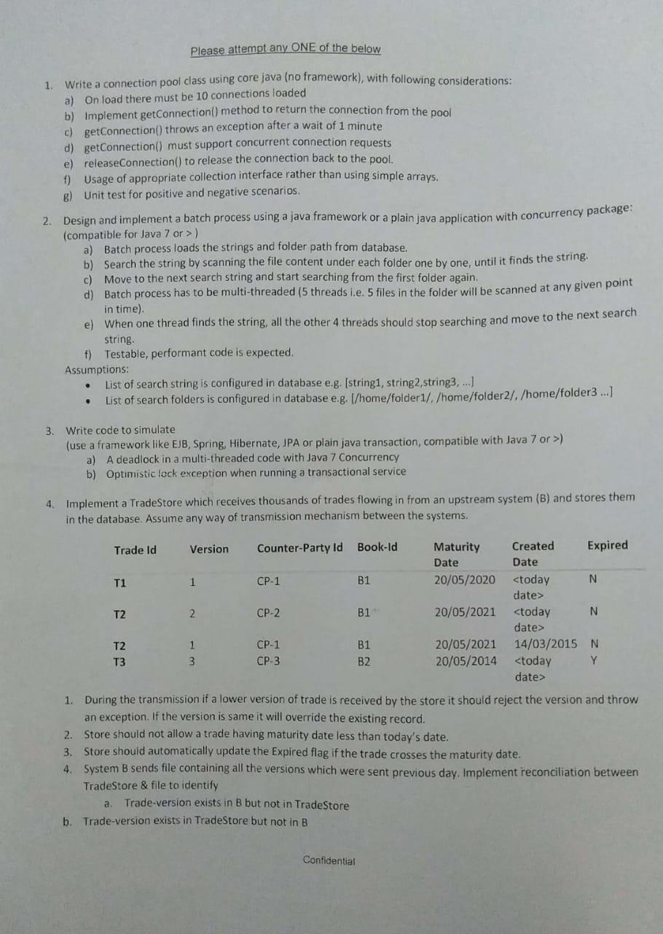

## [SET](https://www.edureka.co/blog/interview-questions/spring-interview-questions/#MVC) -2

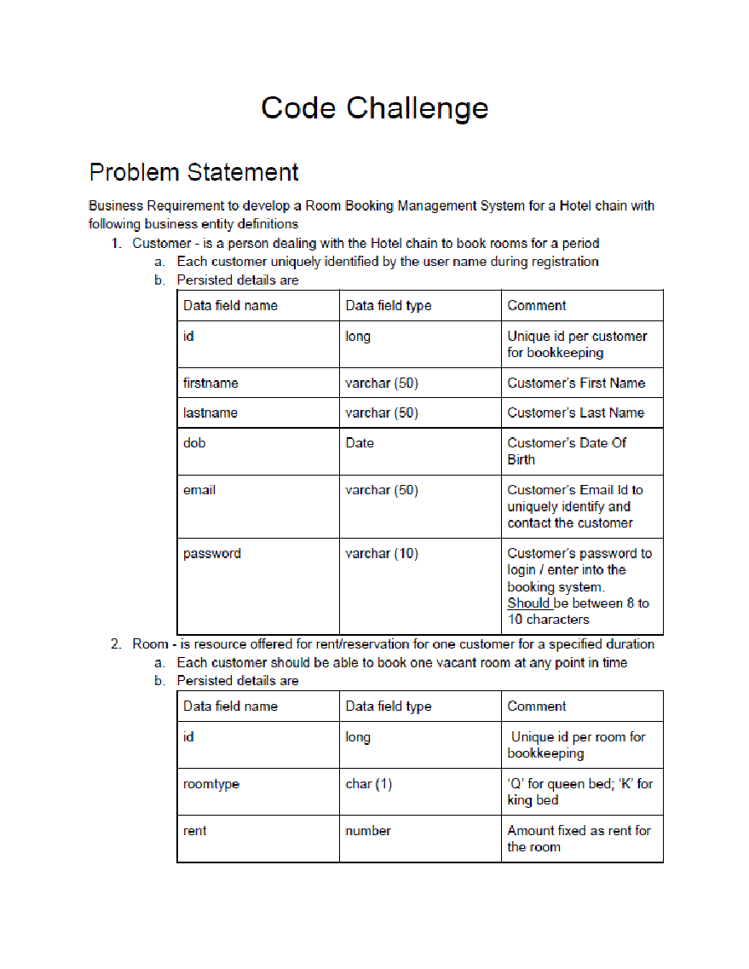

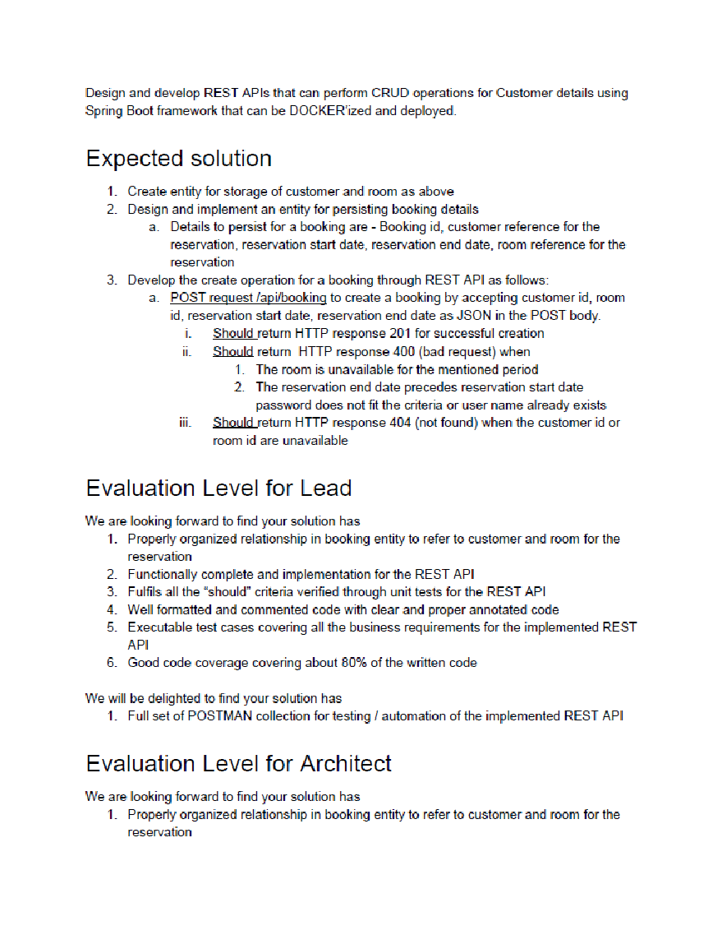

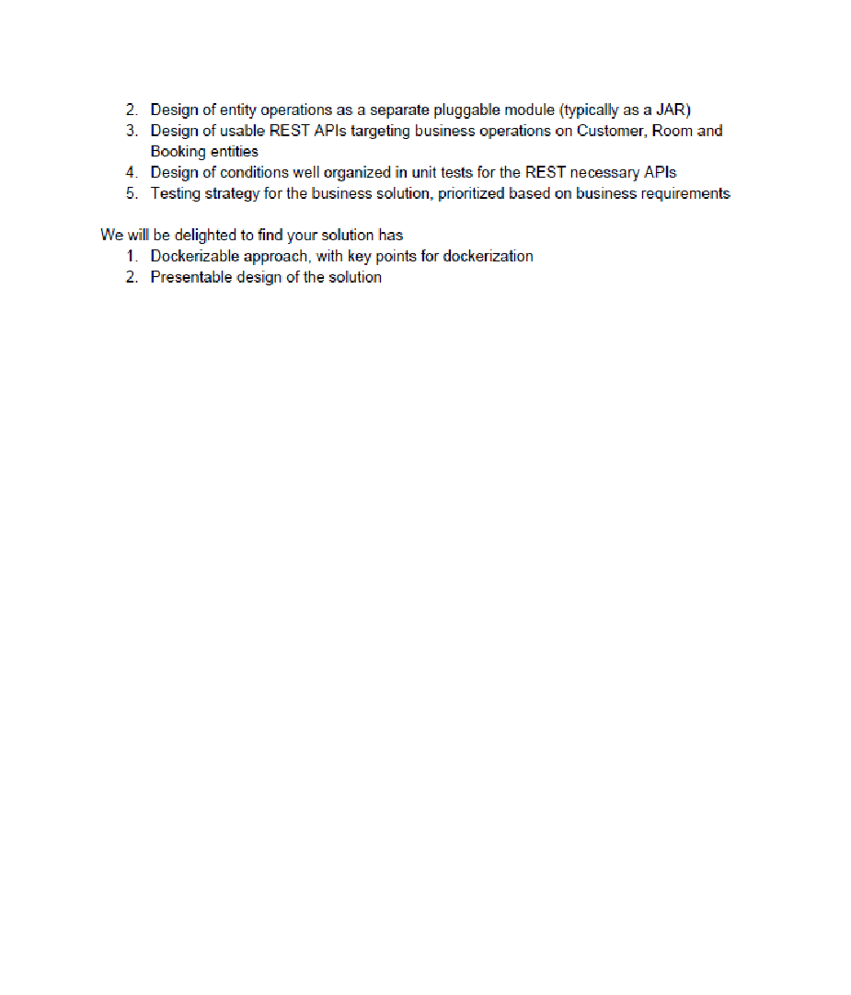

## **PROGRAM1-MEETING OVERLAP**

/*

We are writing a tool to help users manage their calendars. Given an unordered list of times of day when someone is busy, write a function that tells us whether they're available during a specified period of time.

Each time is expressed as an integer using 24-hour notation, such as 1200 (12:00), 1530 (15:30), or 800 (8:00).

Sample input:

meetings = [

[1230, 1300], // 12:30 PM to 1:00 PM

[845, 900], // 8:45 AM to 9:00 AM

[1300, 1500] // 1:00 PM to 3:00 PM

]

Expected output:

isAvailable(meetings, 915, 1215) => true

isAvailable(meetings, 900, 1230) => true

isAvailable(meetings, 850, 1240) => false

isAvailable(meetings, 1200, 1300) => false

isAvailable(meetings, 700, 1600) => false

isAvailable(meetings, 800, 845) => true

isAvailable(meetings, 1500, 1800) => true

isAvailable(meetings, 845, 859) => false

isAvailable(meetings, 846, 900) => false

isAvailable(meetings, 846, 859) => false

isAvailable(meetings, 845, 900) => false

isAvailable(meetings, 2359, 2400) => true

isAvailable(meetings, 930, 1600) => false

isAvailable(meetings, 800, 850) => false

isAvailable(meetings, 1400, 1600) => false

isAvailable(meetings, 1300, 1501) => false

n = number of meetings

r = total minutes in range of all meetings

*/

import java.io.*;

import java.util.*;

public class Solution {

public static void main(String[] argv) {

int[][] meetings = {

{1230, 1300},

{ 845, 900},

{1300, 1500},

};

System.out.println(isAvailable(meetings, 915, 1215));// => true

System.out.println(isAvailable(meetings, 900, 1230));// => true

System.out.println(isAvailable(meetings, 850, 1240));// => false

System.out.println(isAvailable(meetings, 1200, 1300));// => false

System.out.println(isAvailable(meetings, 700, 1600));// => false

System.out.println(isAvailable(meetings, 800, 845));// => true

System.out.println(isAvailable(meetings, 1500, 1800));// => true

System.out.println(isAvailable(meetings, 845, 859));// => false

System.out.println(isAvailable(meetings, 846, 900));// => false

System.out.println(isAvailable(meetings, 846, 859));// => false

System.out.println(isAvailable(meetings, 845, 900));// => false

System.out.println(isAvailable(meetings, 2359, 2400));// => true

System.out.println(isAvailable(meetings, 930, 1600));// => false

System.out.println(isAvailable(meetings, 800, 850));// => false

System.out.println(isAvailable(meetings, 1400, 1600));// => false

System.out.println(isAvailable(meetings, 1300, 1501));// => false

}

public static booleanisAvailable(int[][] meetings, intst, int et){

boolean available=true;

for(inti=0; i<meetings.length; i++){

if(outOfBoundary(meetings[i][0], meetings[i][1], st, et)){

available = true;

} else {

available = false;

break;

}

}

return available;

}

public static booleanoutOfBoundary(intscheduleStartTime, intscheduleEndTime,intst, int et){

if(st>= scheduleStartTime&&st<scheduleEndTime){

if(et >scheduleStartTime&& et <= scheduleEndTime){

return false;

}

}

if(st<scheduleStartTime){

if(et >scheduleStartTime&& et <= scheduleEndTime){

return false;

}

}

if(st<scheduleEndTime&& et>scheduleEndTime){

return false;

}

return true;

}

}

Design URL Shortener

*************************************************************************************************************

Problem Statement

Read : 1000 TPS (transaction per second)

Write : 10 TPS (transaction per second)

URL TTL (expiry) : 1 year

Other Features : Multiple organizations

Other Features : Analytics

User agent

Longitude / Latitude

Device Identifier

CTR (click through rate)

and other parameters ...

Other Features : Easily scalable solution to 100 X

*************************************************************************************************************

Solution

paytm.com/v1/airtel/recharge/dotransactions ⇒ pay.tm/ABCED

Market pay.tm/ABCED ⇒ it open paytm.com/v1/airtel/recharge/dotransactions

pay.tm/ABCHEDS ⇒ paytm.com/v1/airtel/recharge/dotransacti?your-order-id=123

—----------------------------------------------------------------------------------------------------------------------------------

